
Western Mathematics
2014 Year 10
Yearly Examination
Mathematics Course
Solutions

2014 Yearly Advanced Mathematics Exam
Short Answer Questions
Answers
The temperatures in increasing order are :

-15º C, -6º C, -2º C, 0º C and 3º C

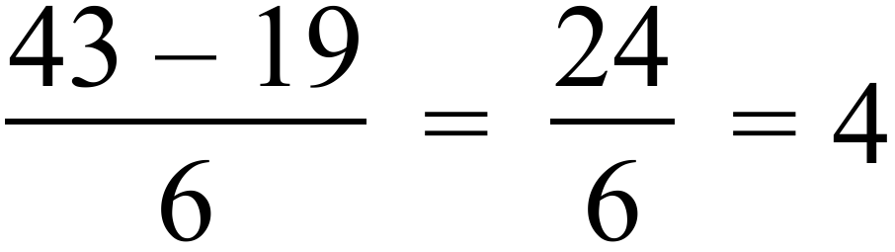
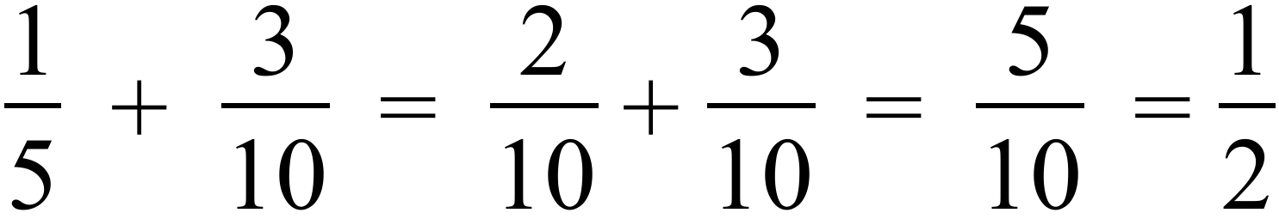
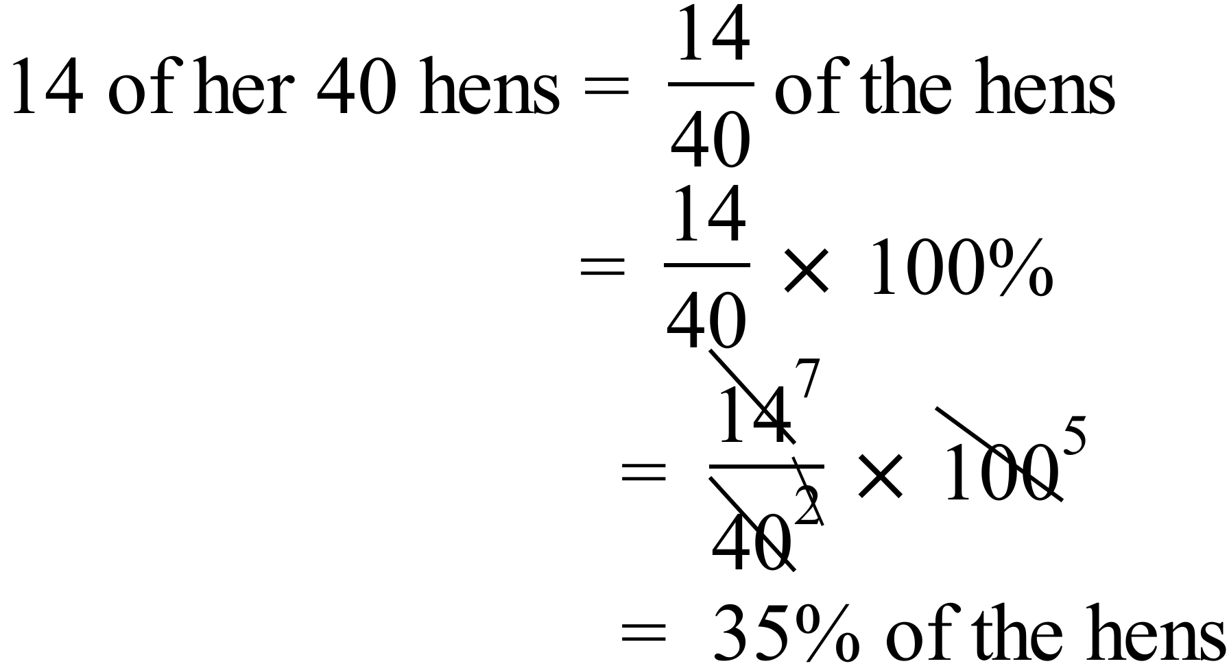
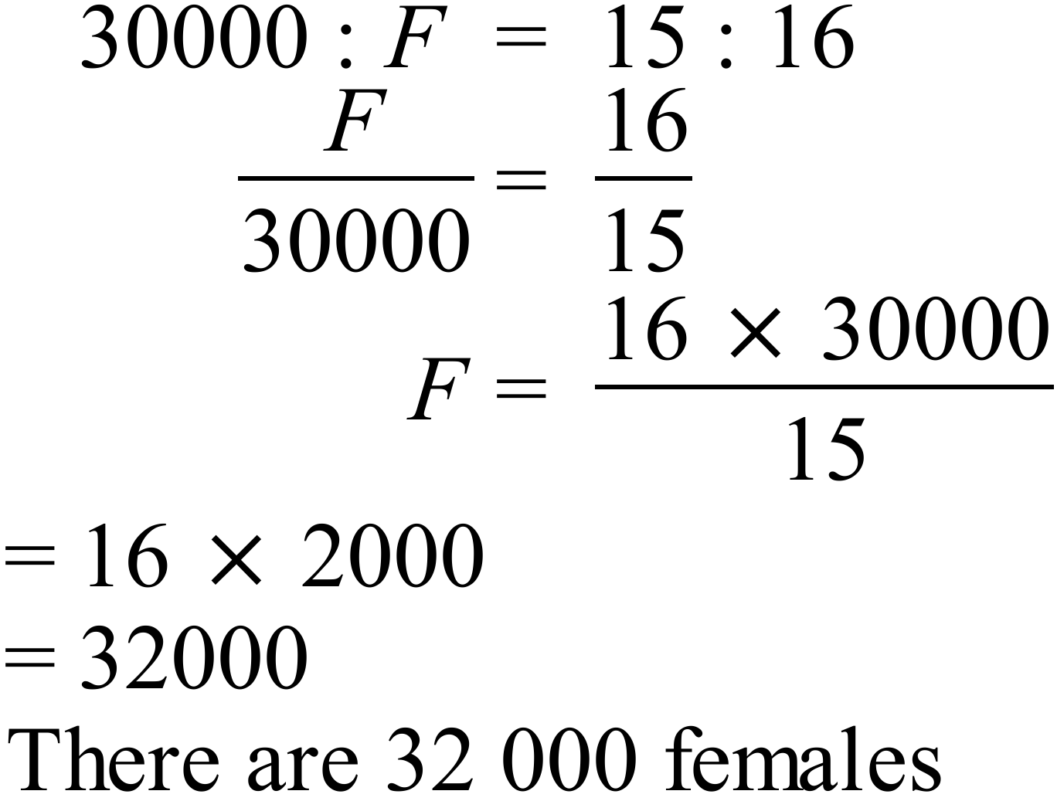
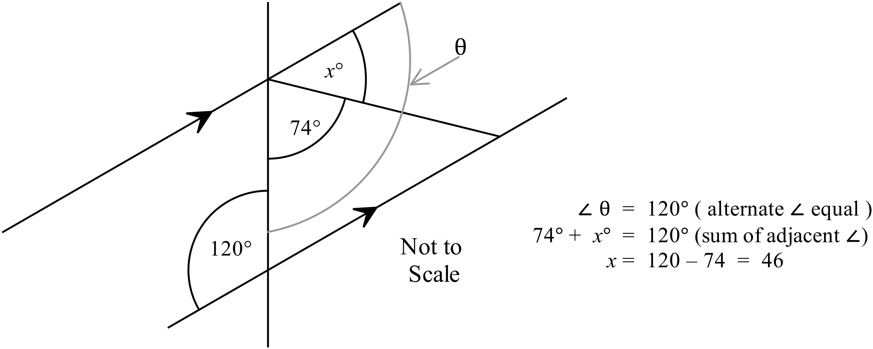

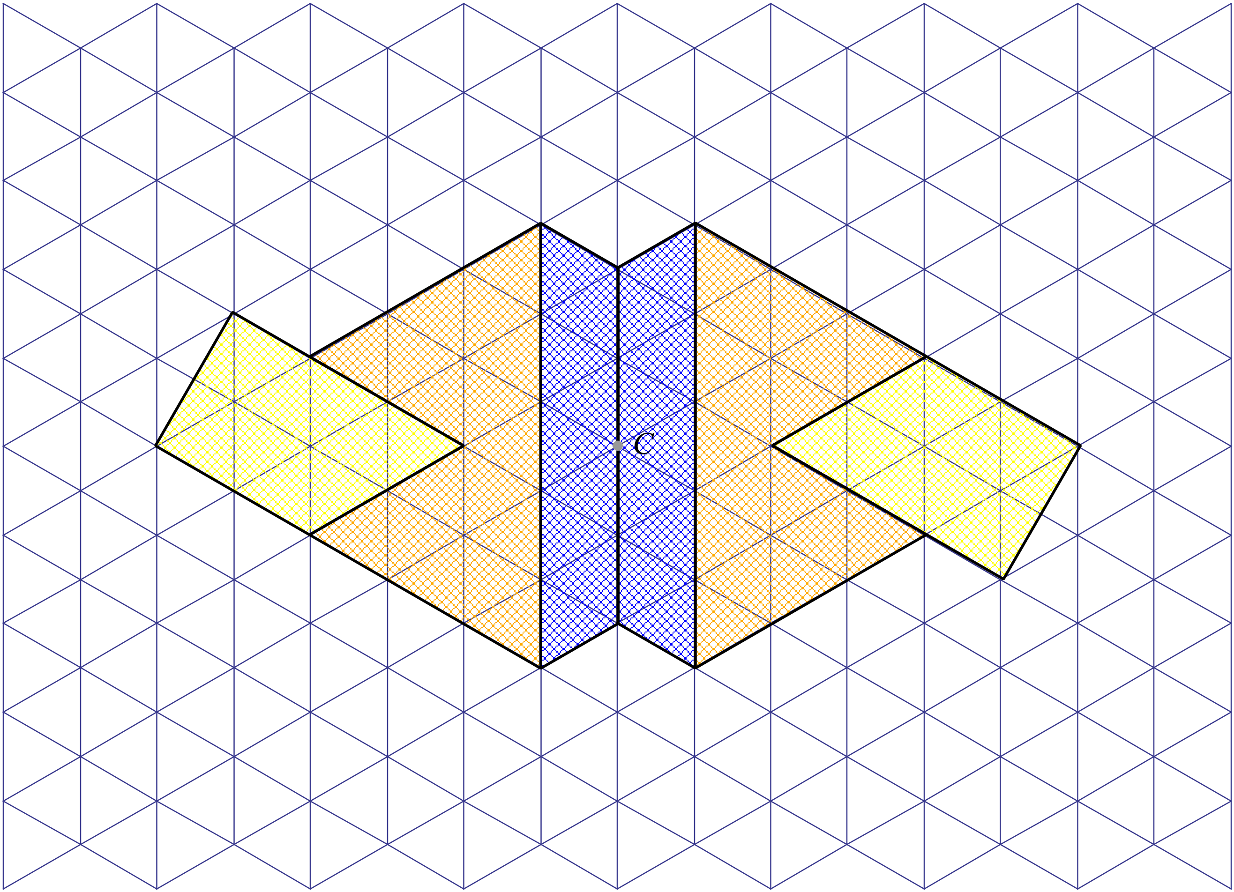

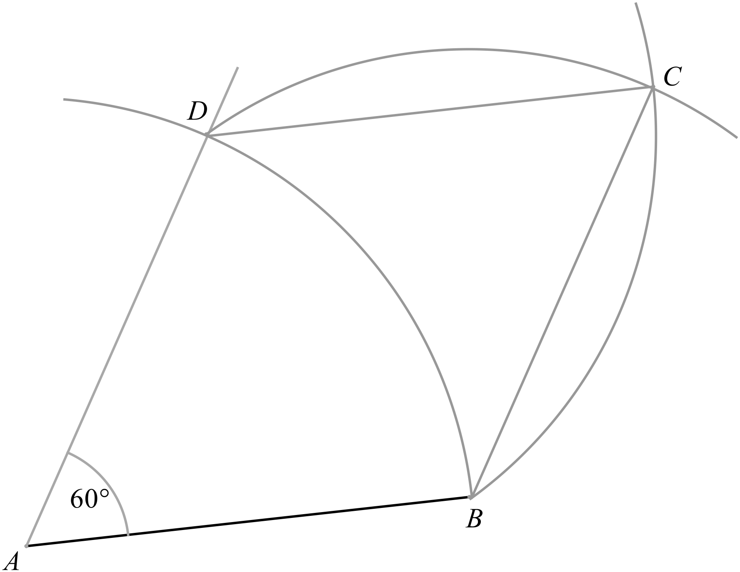

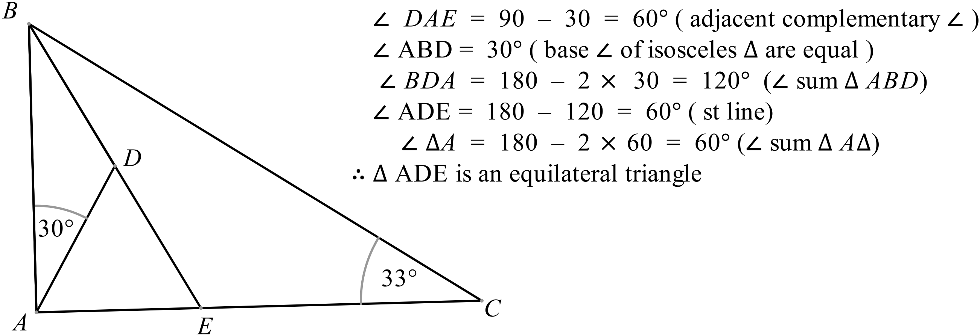

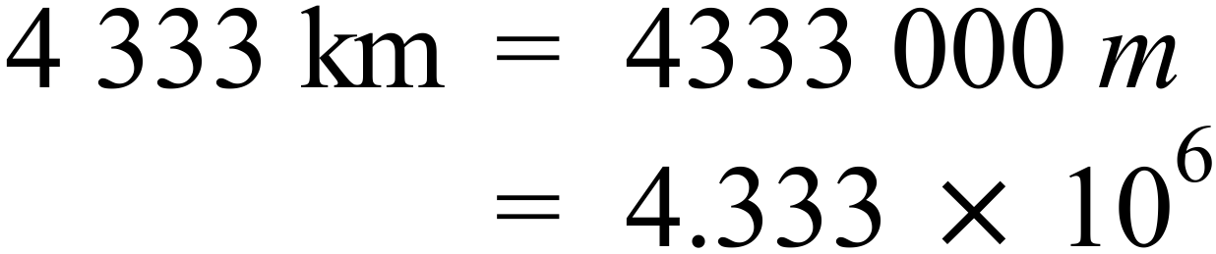
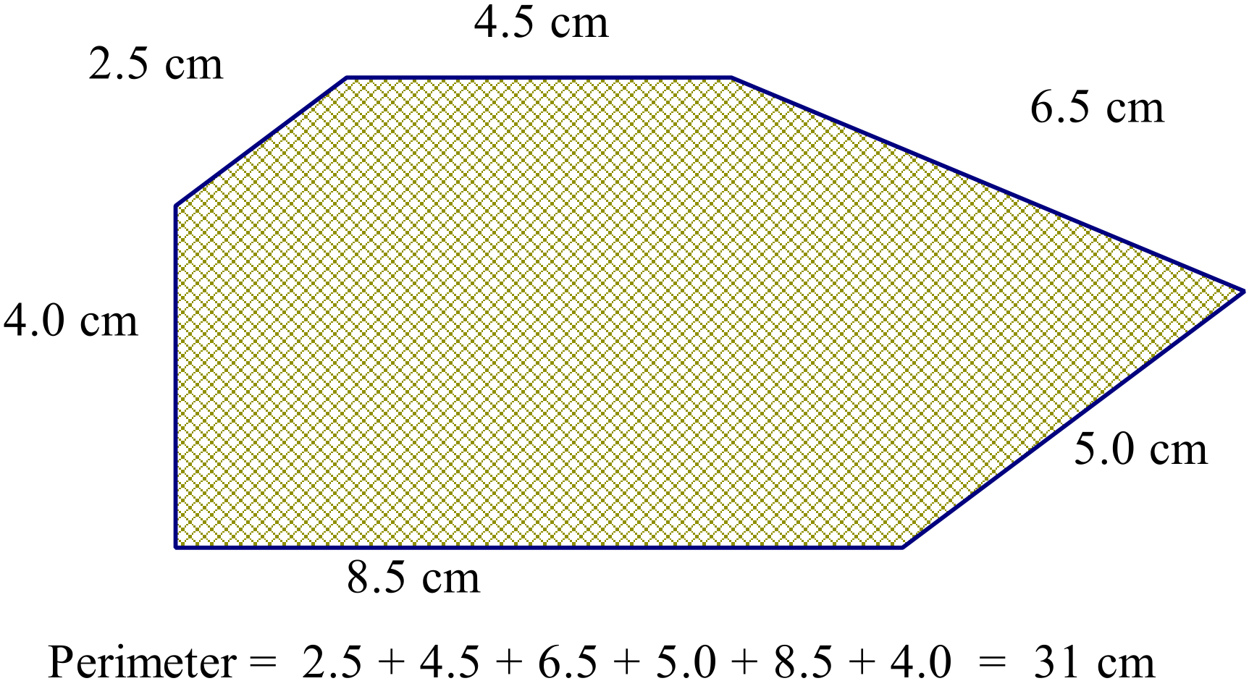

NB Different printers will produce small differences in the sizes of the diagram. Check your own printed copy by measuring, before marking student responses.

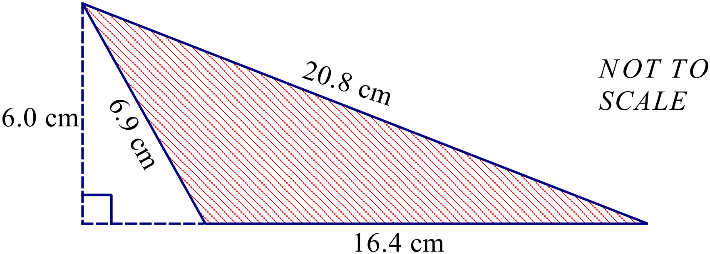

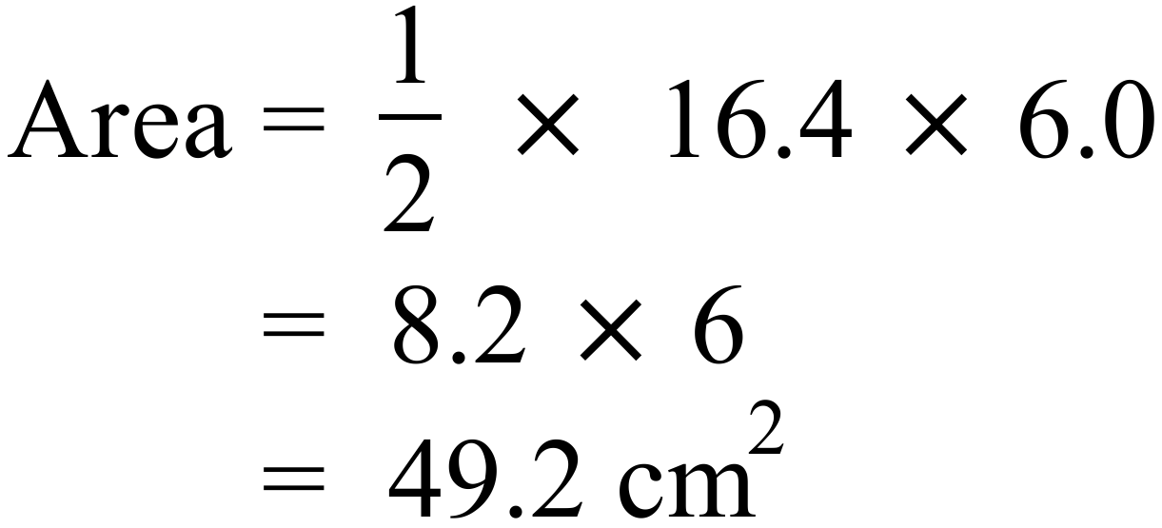

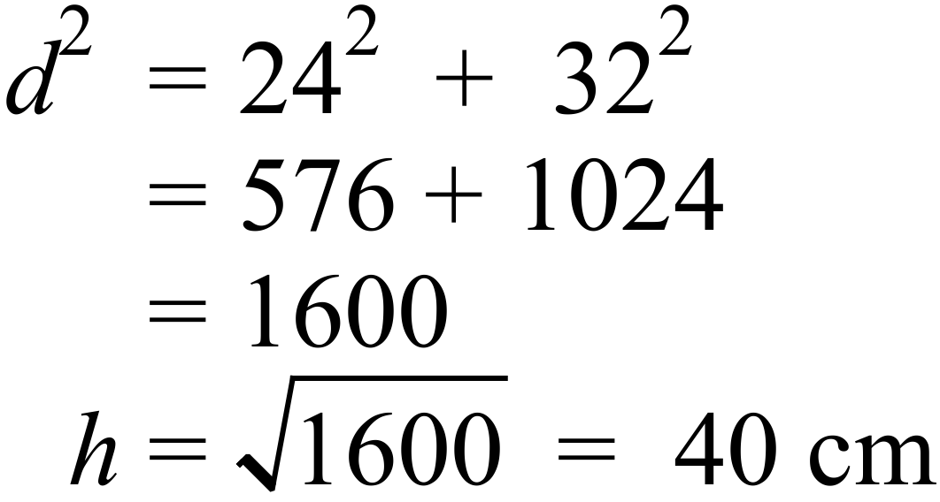
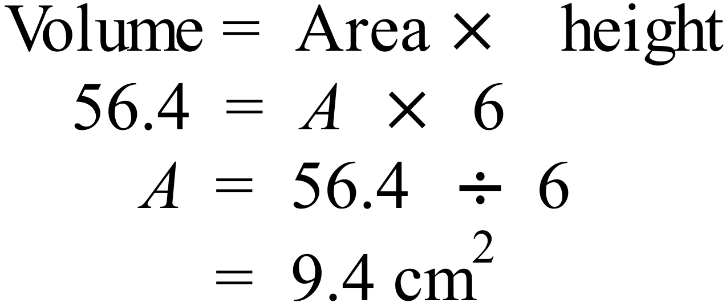
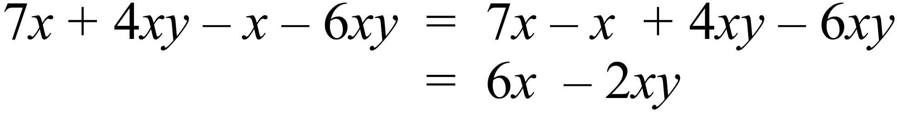
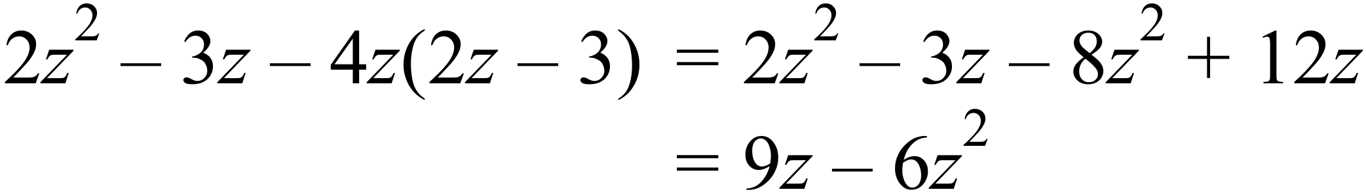
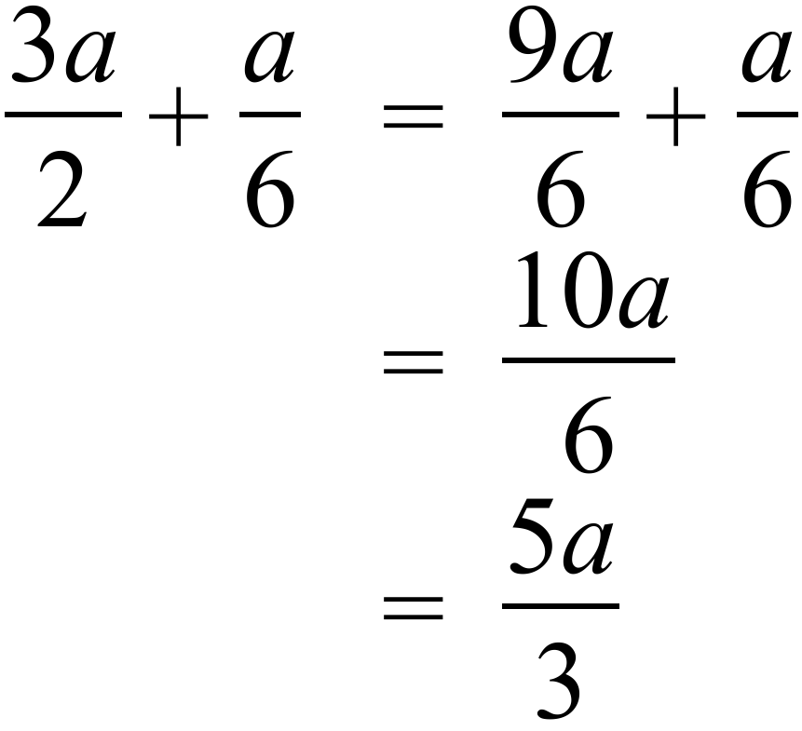
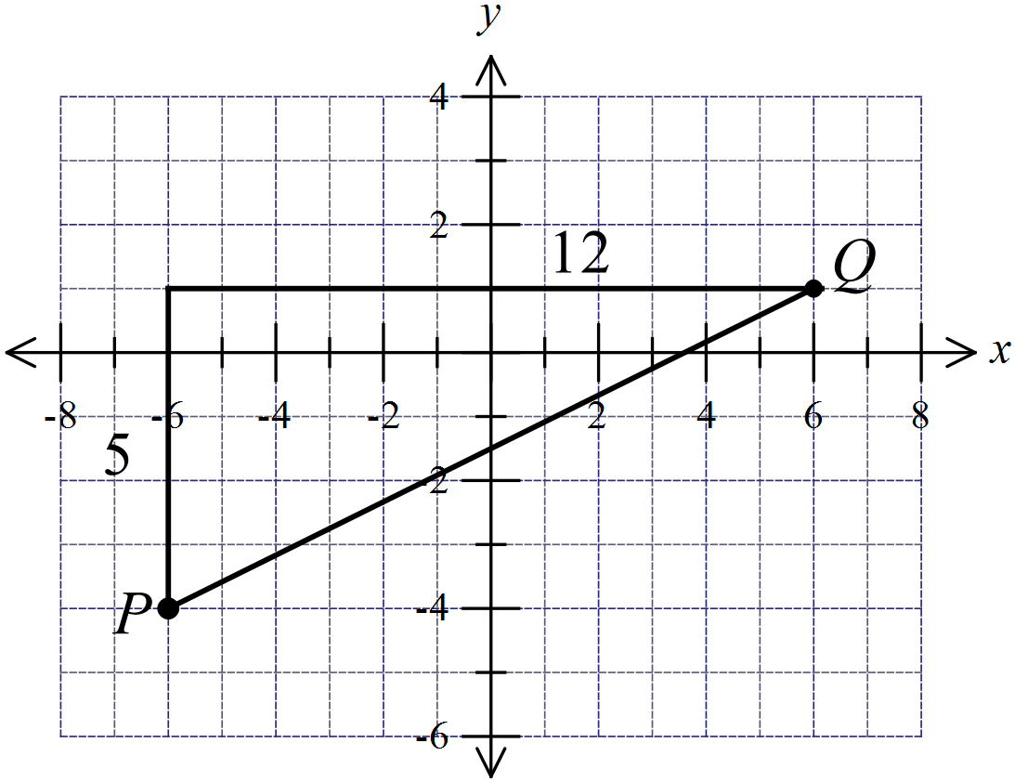

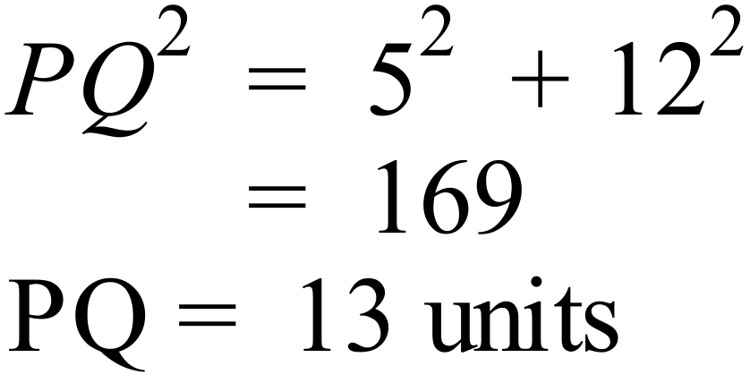

Or by using the distance formula

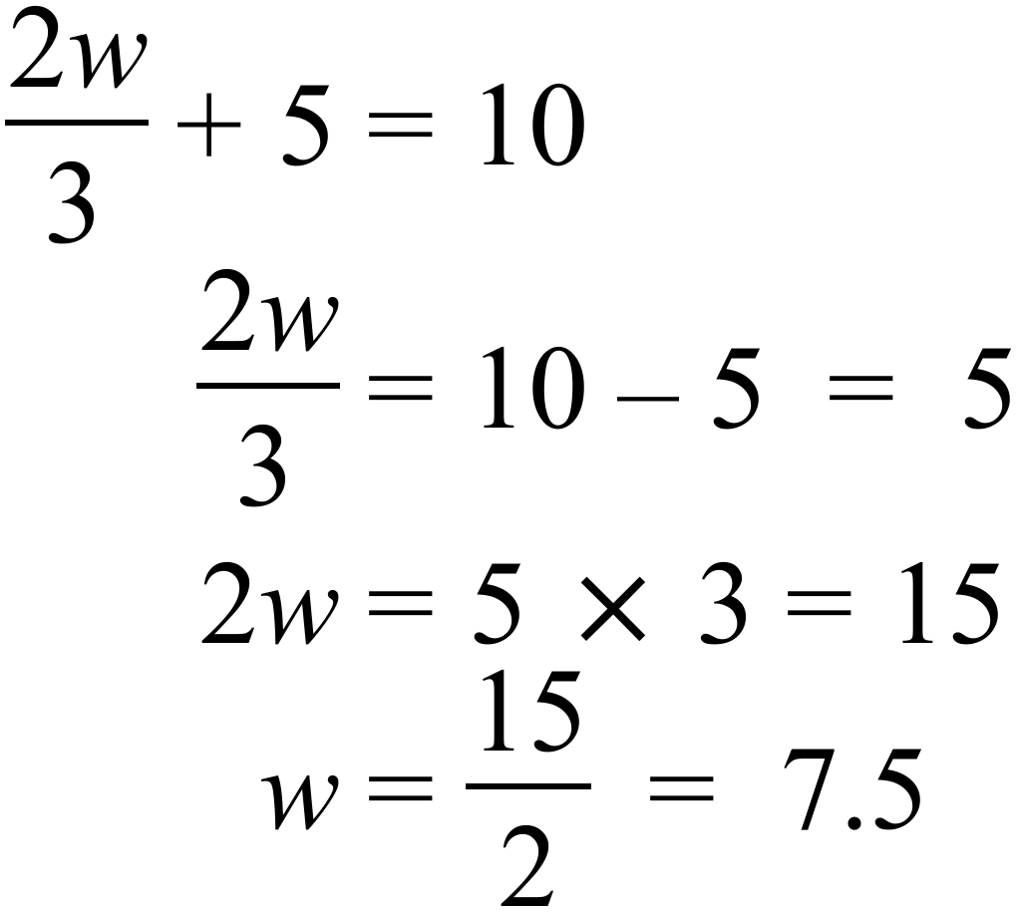
42 | 15 | 27 | 34 | 62
72 | 48 | 18 | 33 | 55
37 | 52 | 15 | 32 | 17
57 | 44 | 38 | 19 | 22

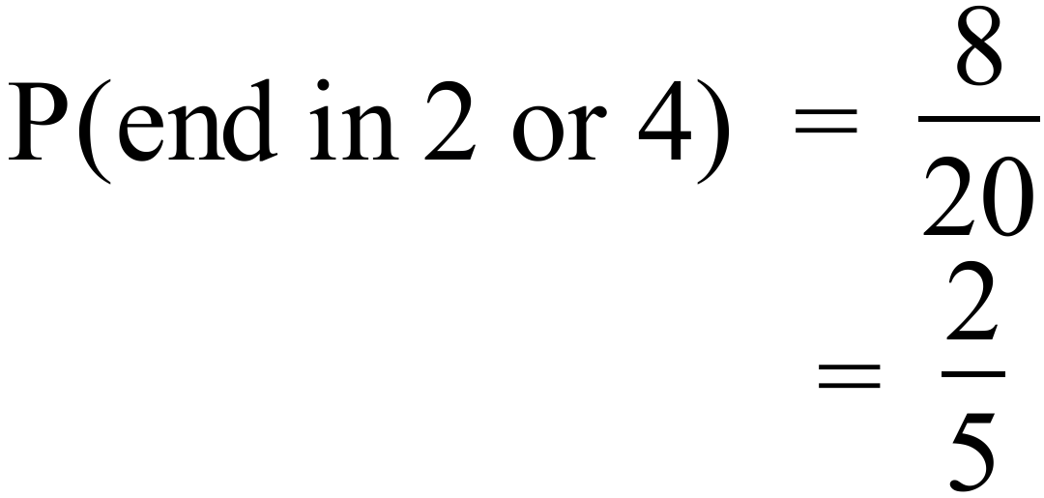
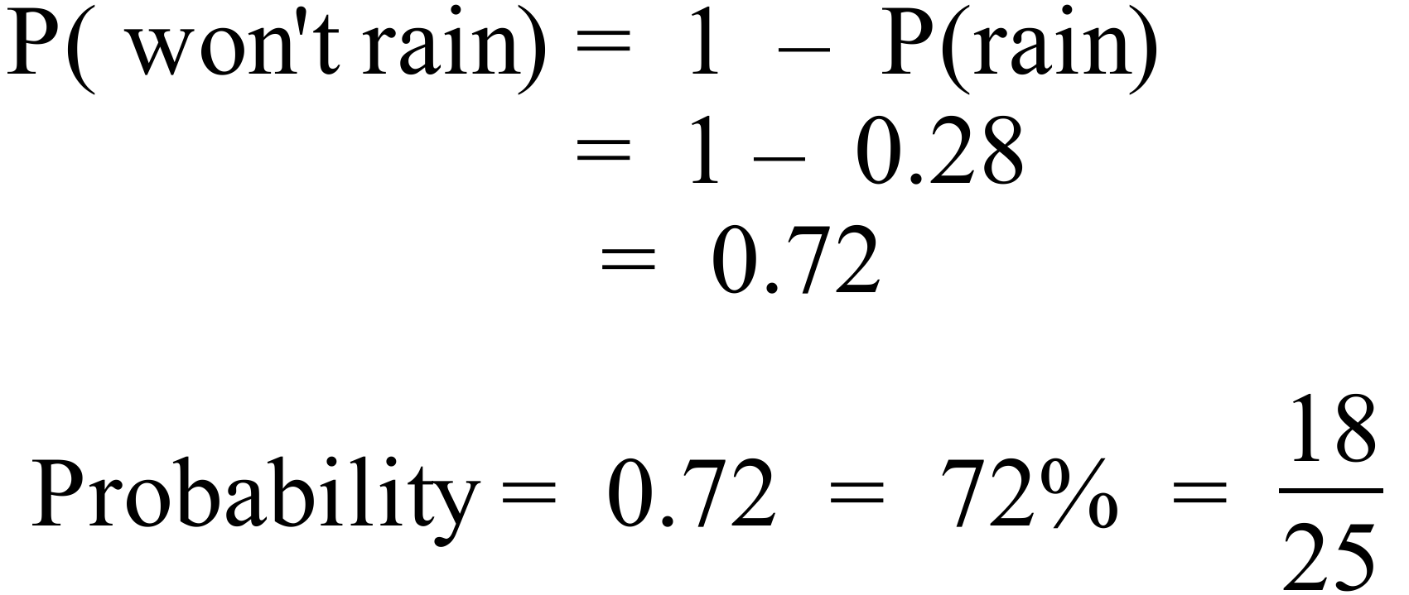
0 | 2
1 | 1 | 2
2 | 2 | X
3 | 0 | 2 | 3
4 | 2 | 3
5 | 0

Sum of scores given = 2+11+12+22+30+32+33+42+43+50 = 277
Missing score = 301 – 277 = 24
The X represents 4 to make 24.
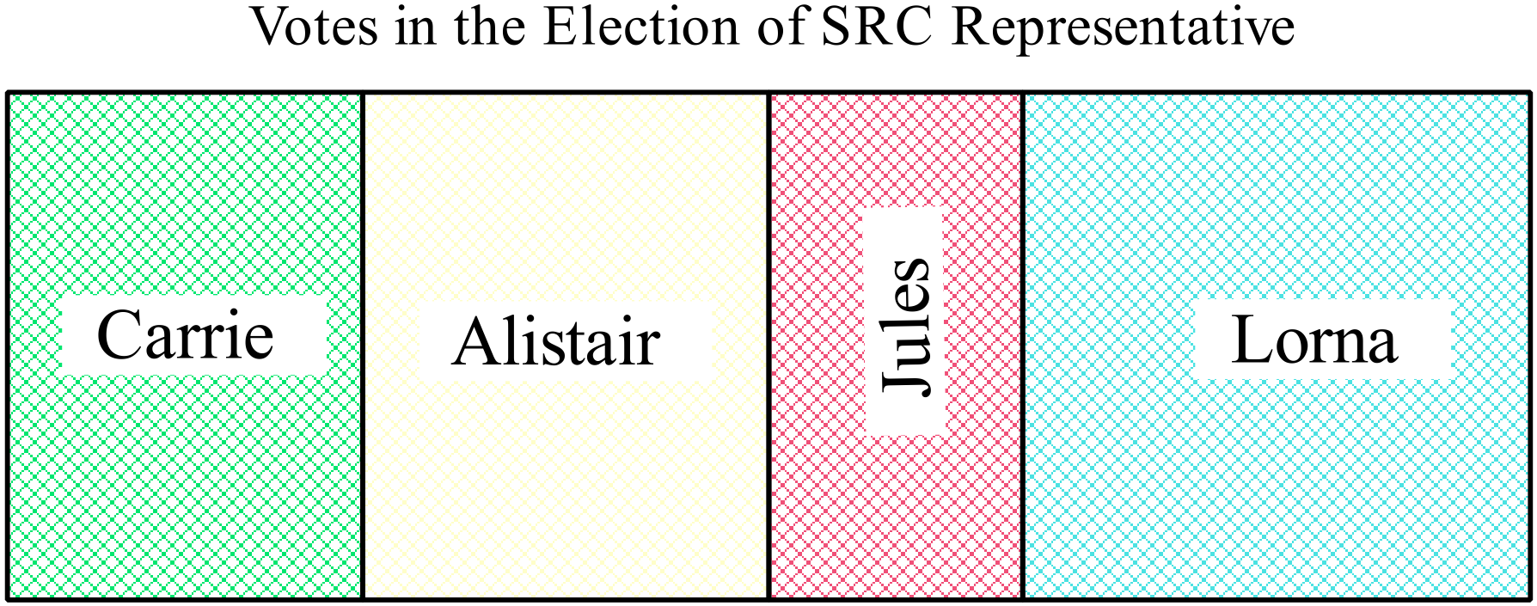

Length of whole graph = 12 cm and of winner (Lorna) = 4 cm.
Votes for Lorna = 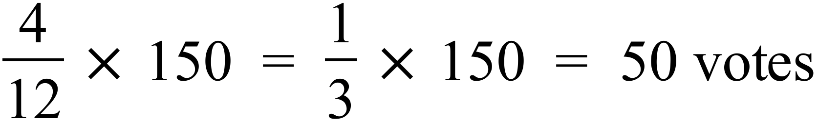
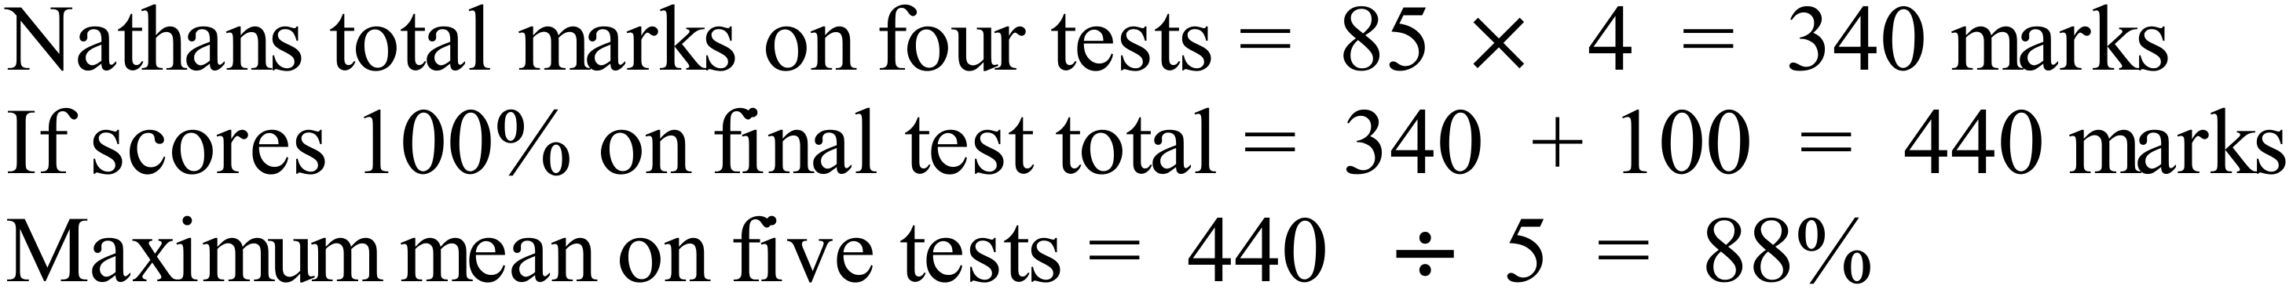
Arrange in order first.

11.0, 11.1, 11.2, 11.4, 11.4, 11.6, 11.9, 12.0, 12.1, 12.5

Lower Q Median = 11.5 Upper Q

Interquartile range = 12.0 – 11.2 = 0.8

2014 Yearly Advanced Mathematics Exam
Multiple Choice Section
Answers
 | 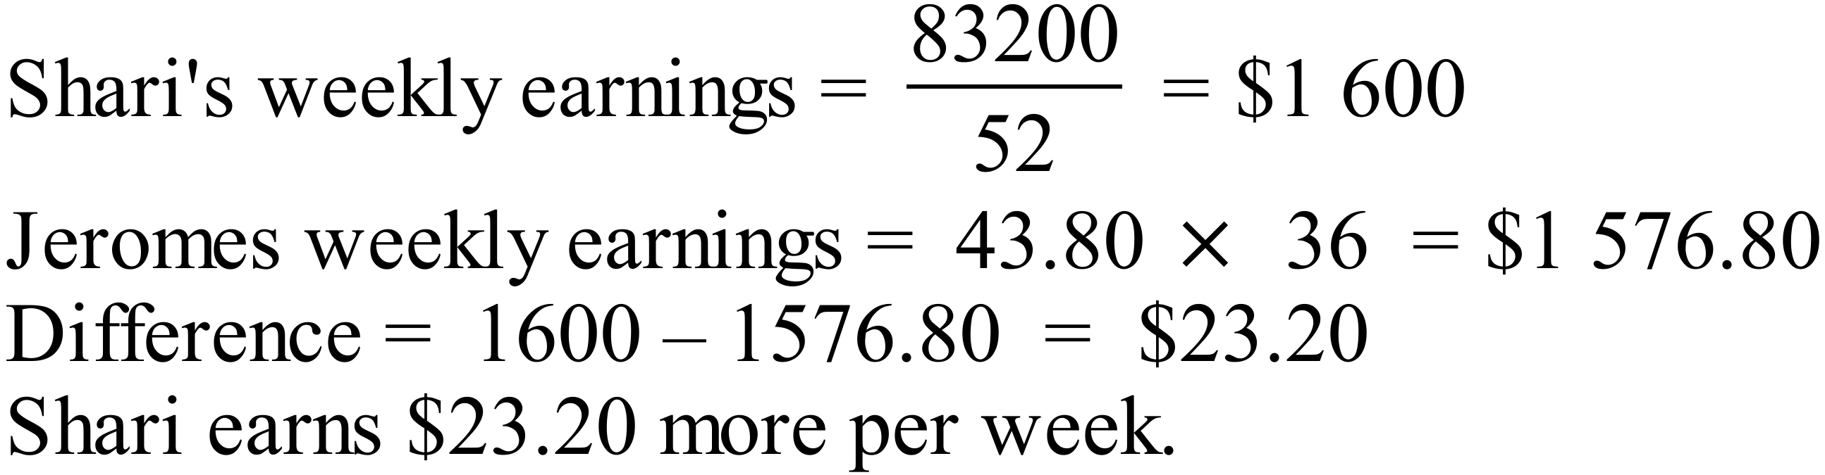 | C
 | 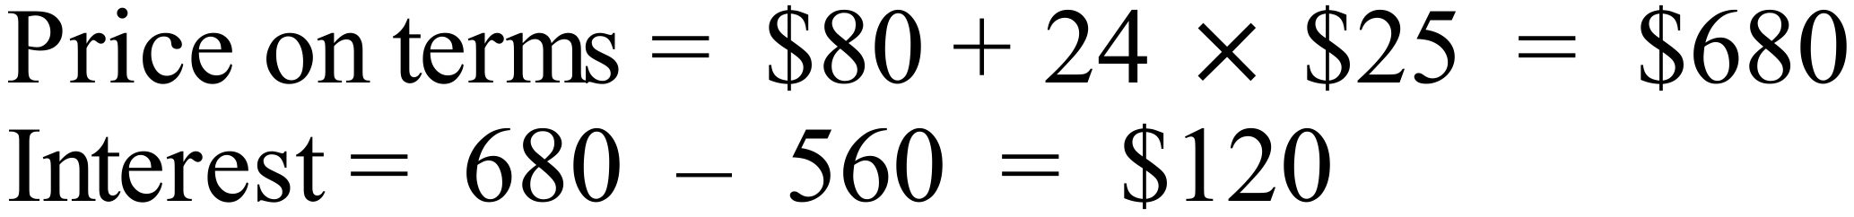 | B
 | 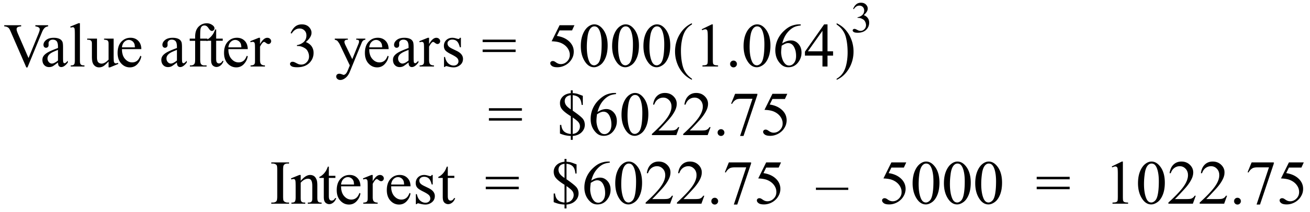 | B
 | Value has halved when it reaches $20 000.  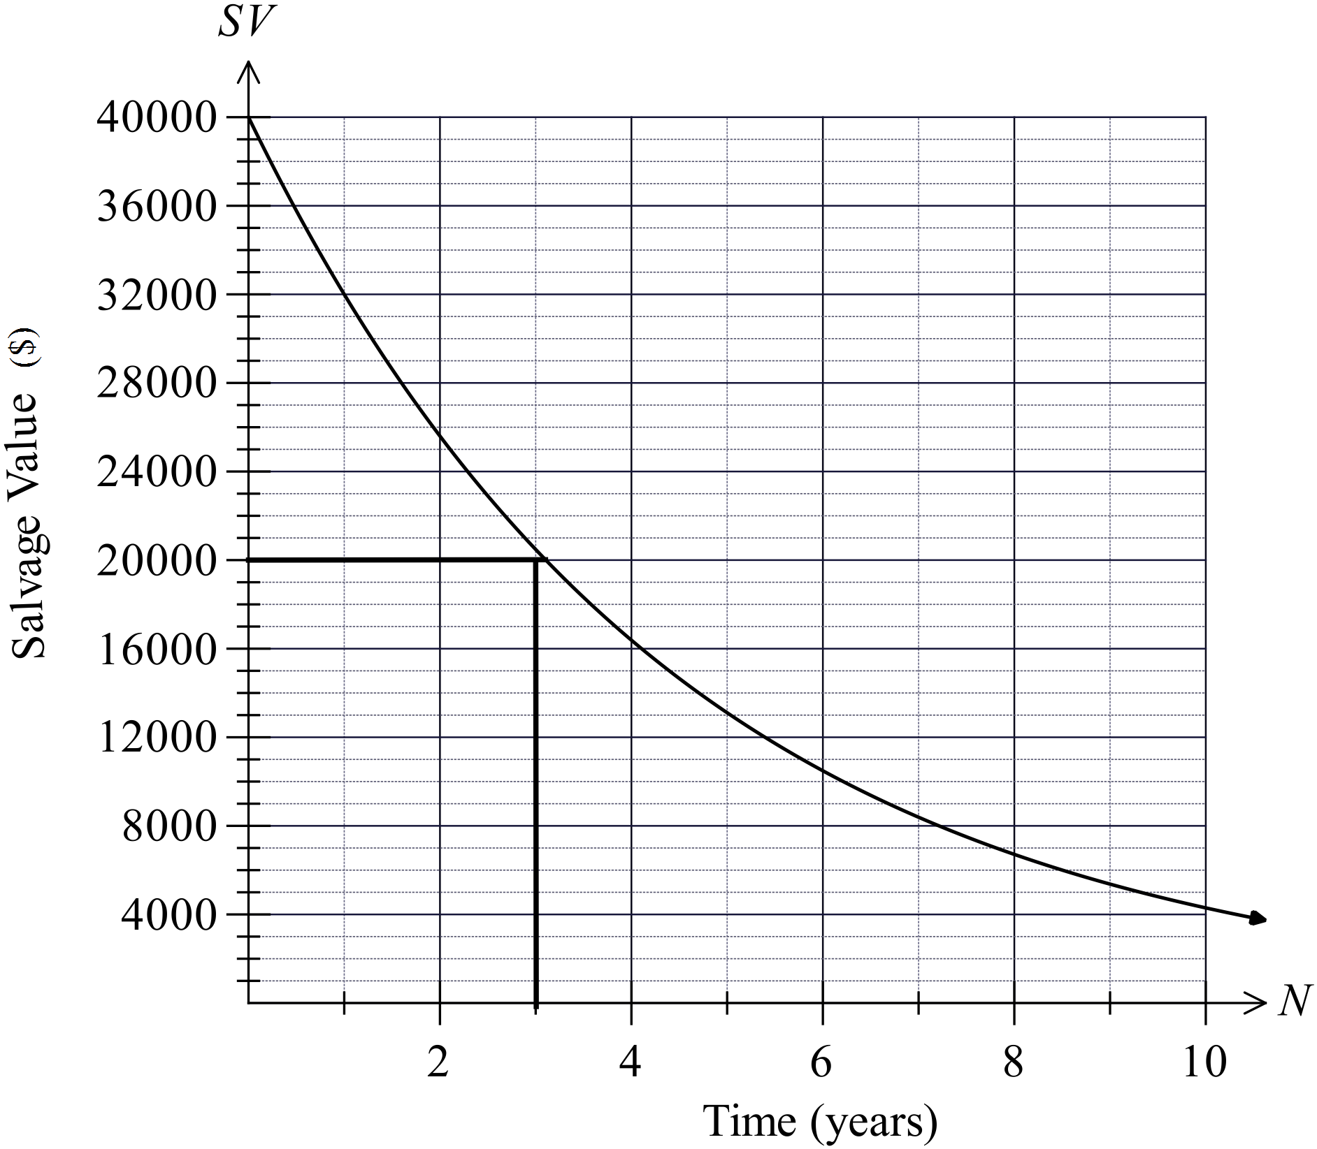  From Graph this is after 3 years. | D
 | 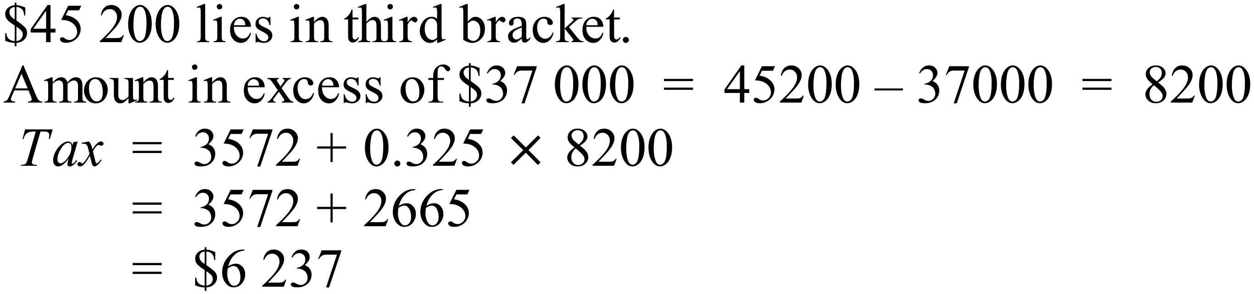 | D
 | 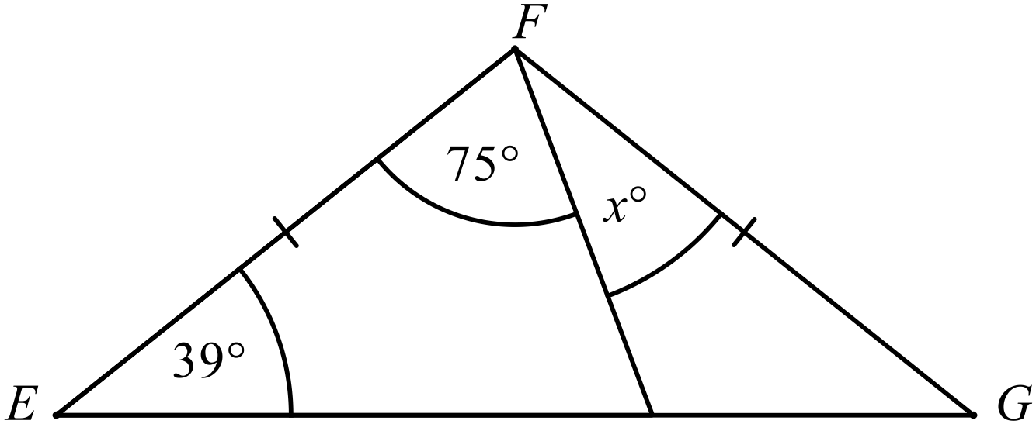  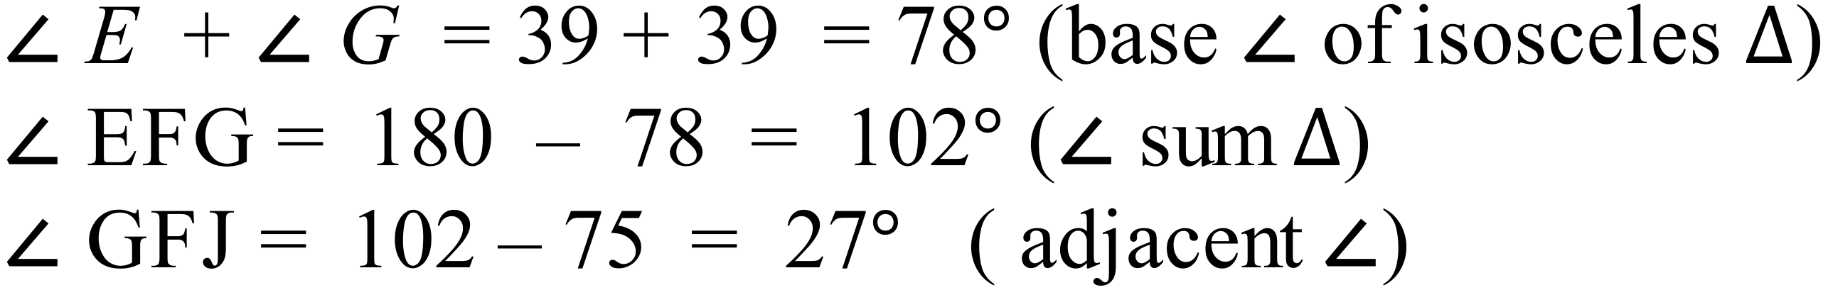 | A
 | 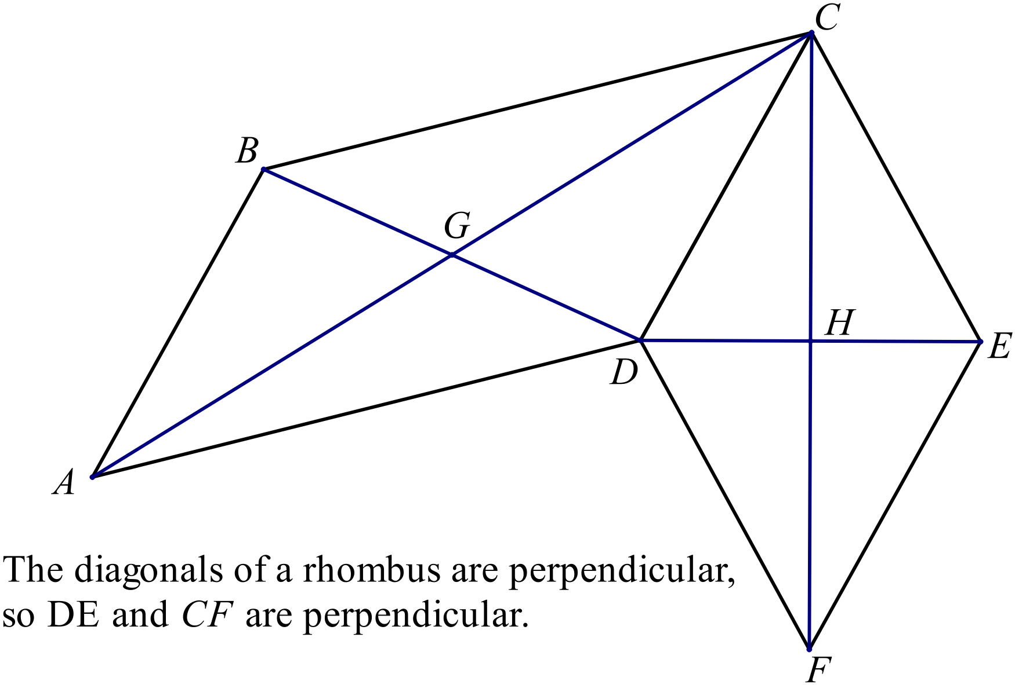 | D
 | 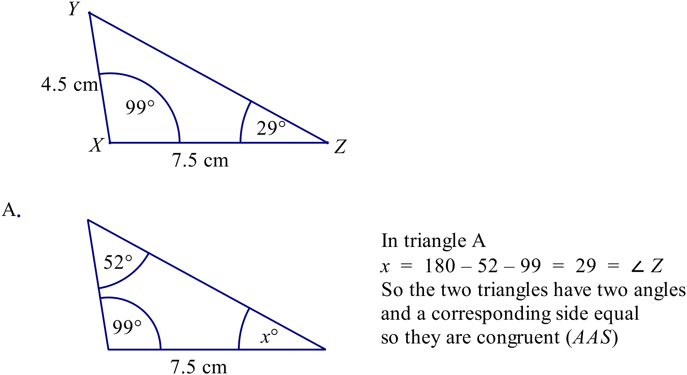 | A
 | 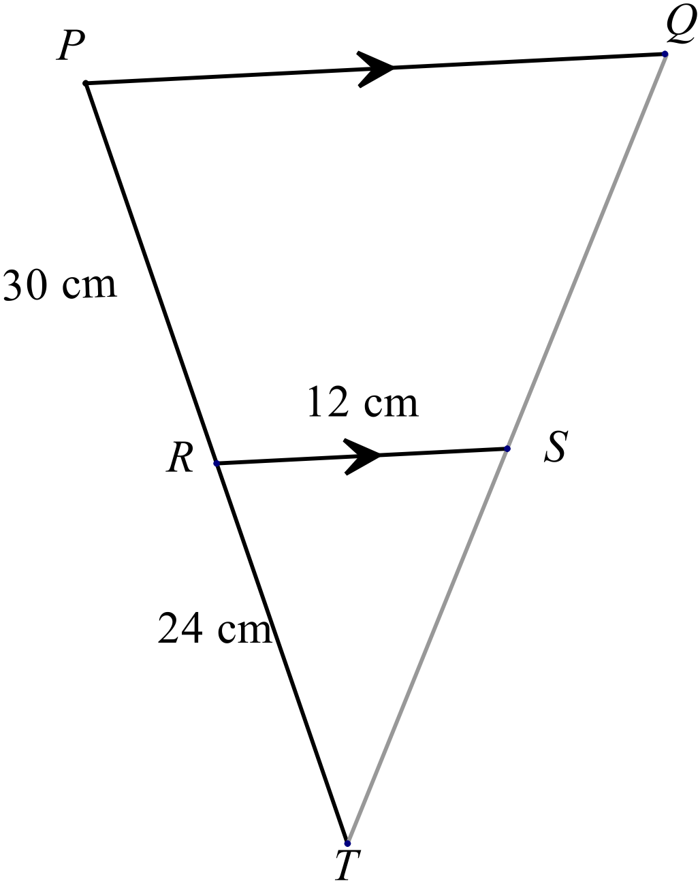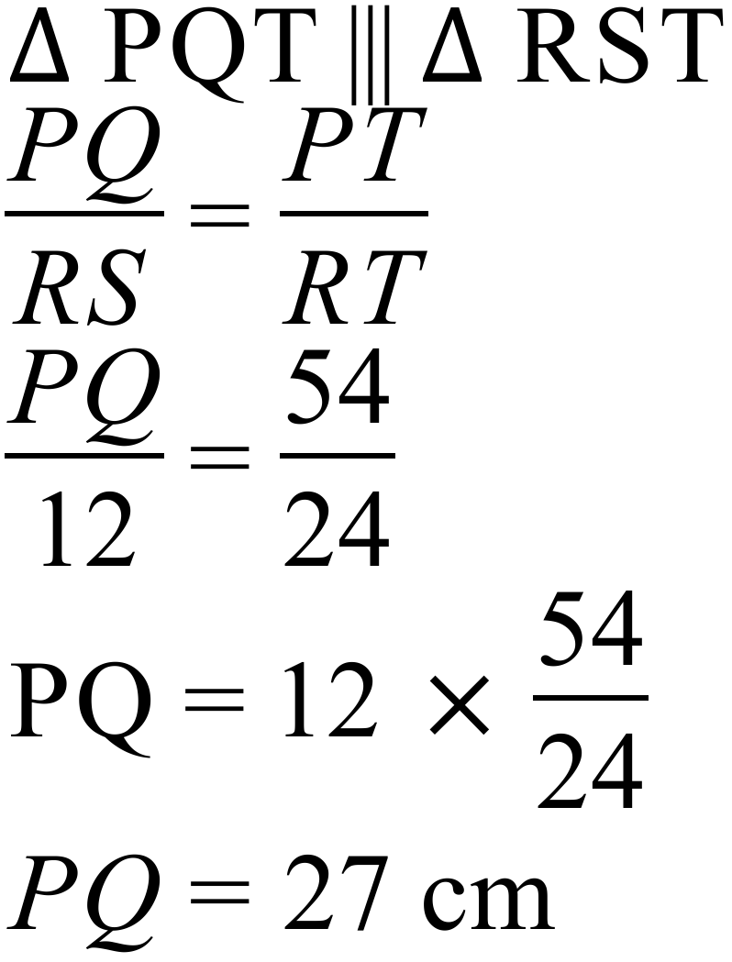 | C
 | 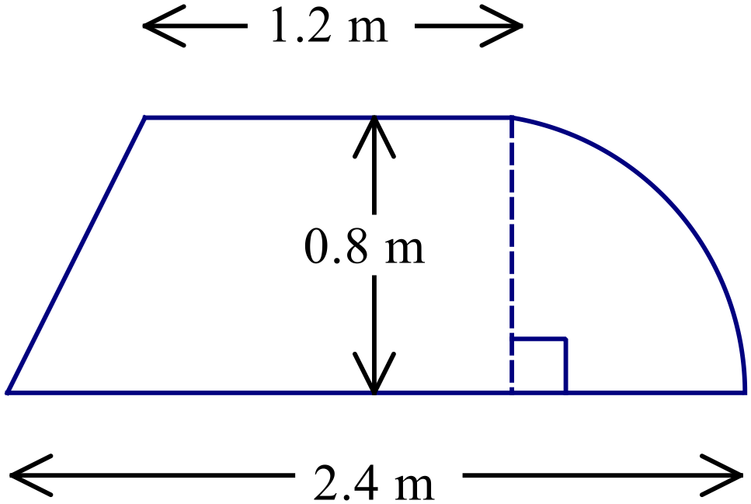  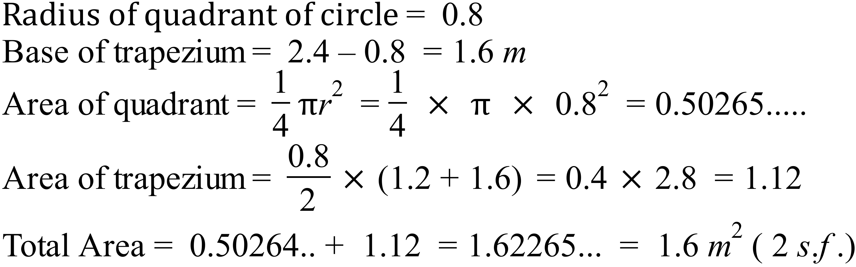 | C
 | 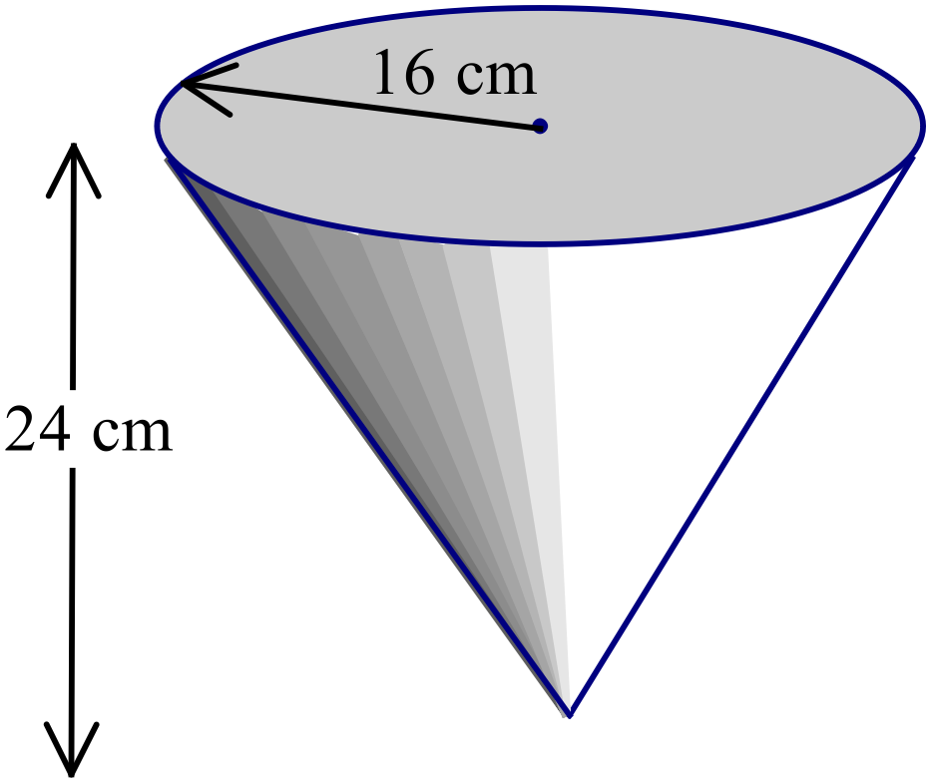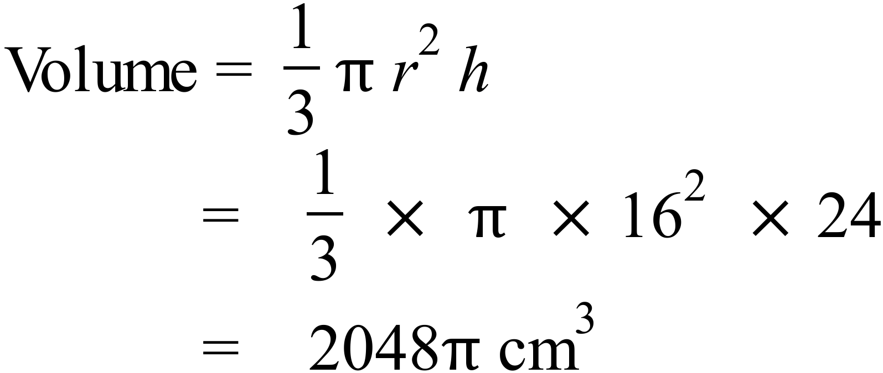 | D
 | 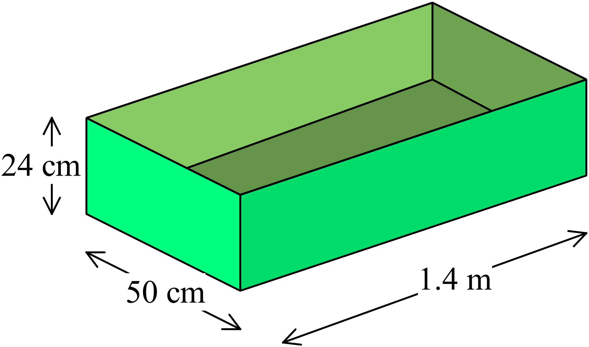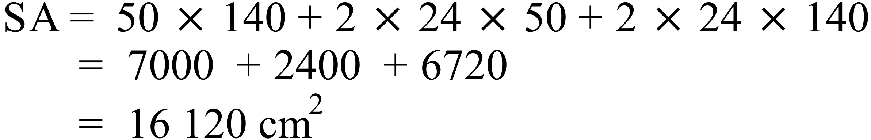 | C
 | 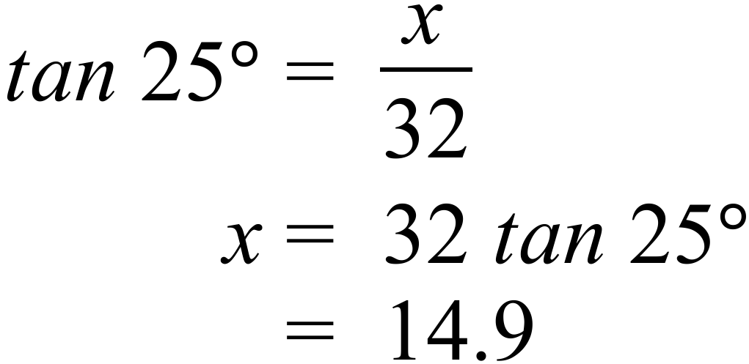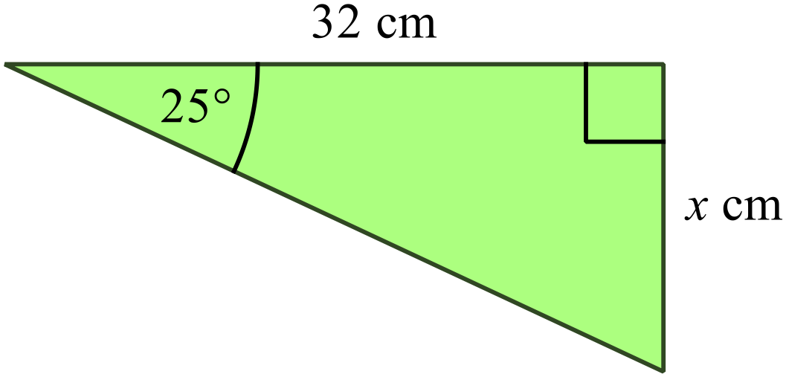 | B
 | 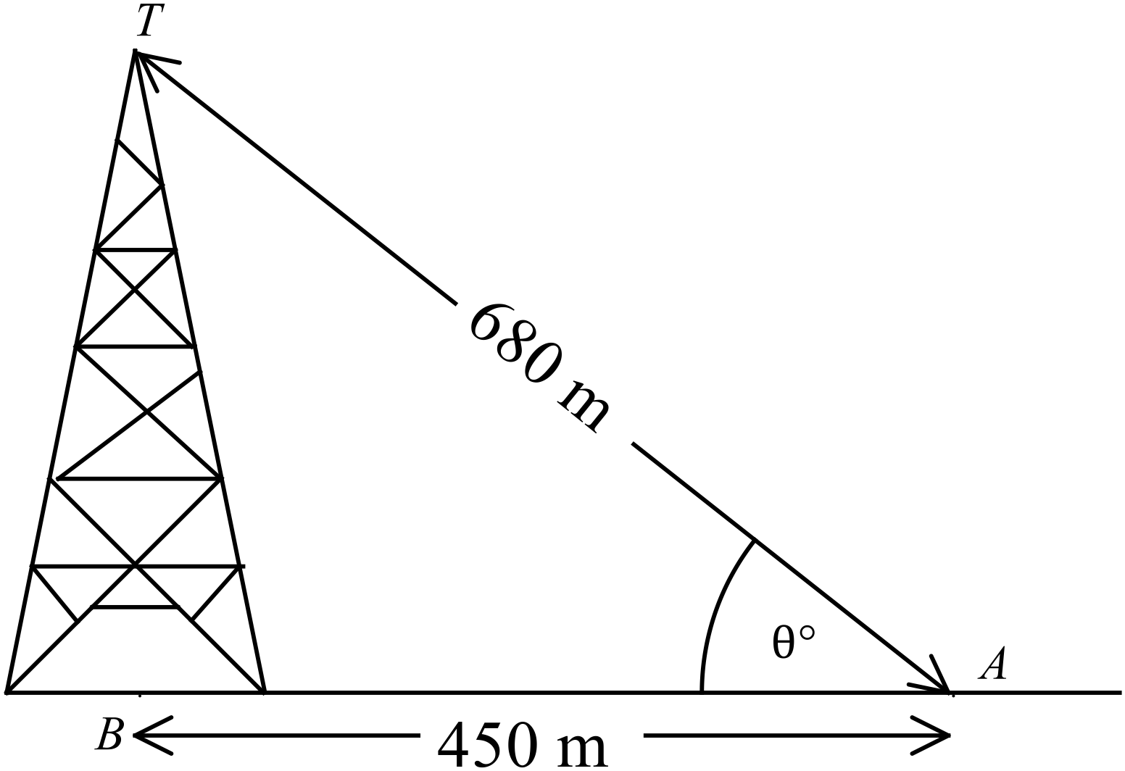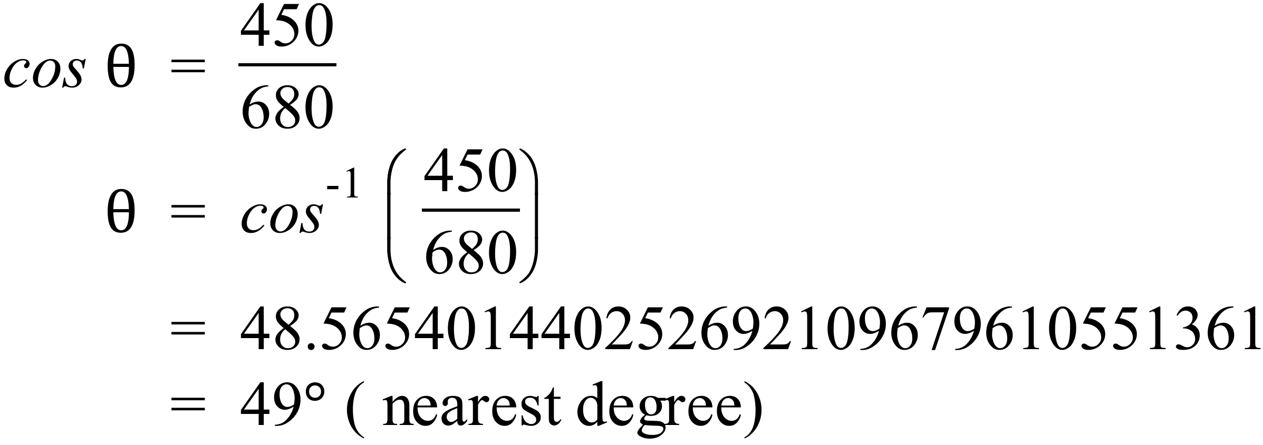 | C
 | 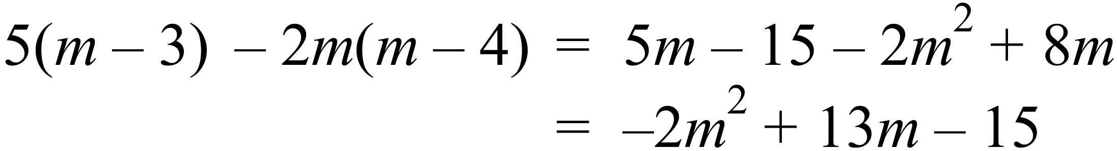 | B
 | 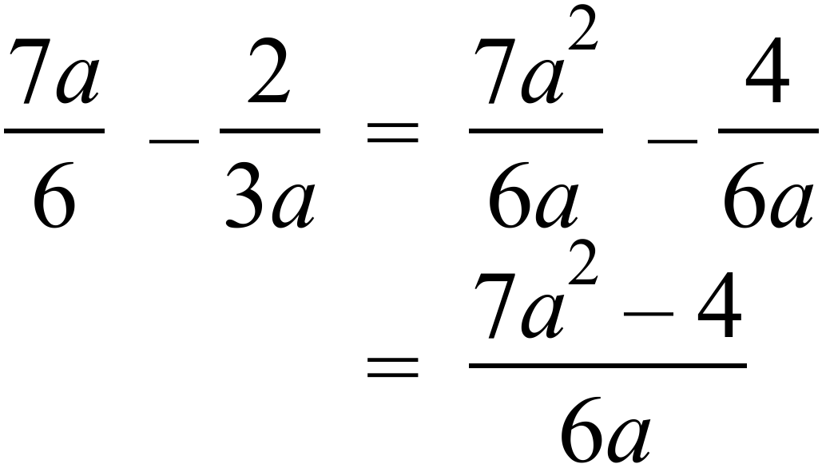 | D
 | 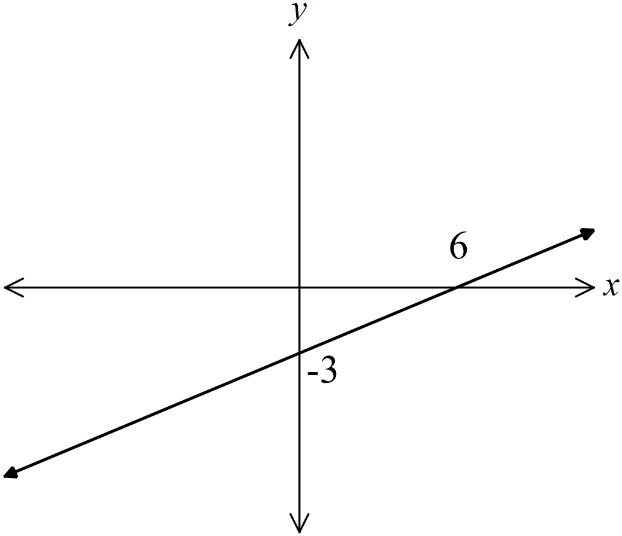 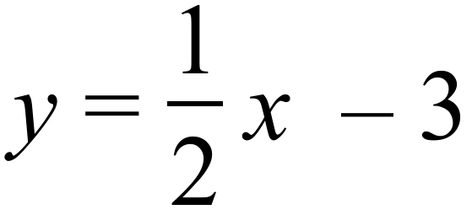 has a gradient of 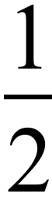 and a y intercept of -3.  A. | A
 | Noah’s average speed on his return journey = 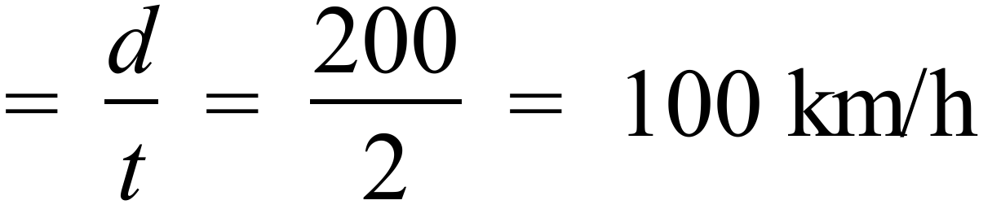  So statement A is incorrect. The oters are all correct. | A
 | The others are all euqual to 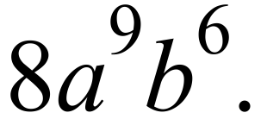 | B
 | A and B both include equality signs so do not match the graph 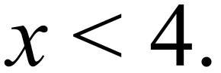  C has solution with inequality in opposite direction.  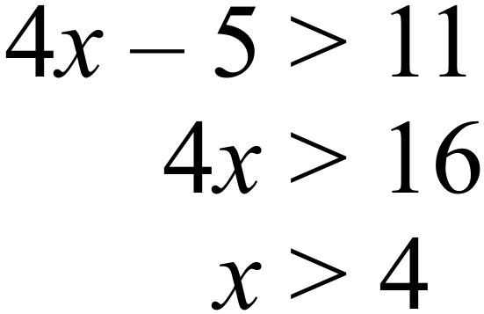  D has correct solution  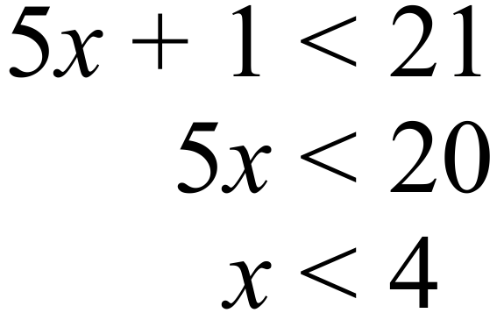 | D
 | 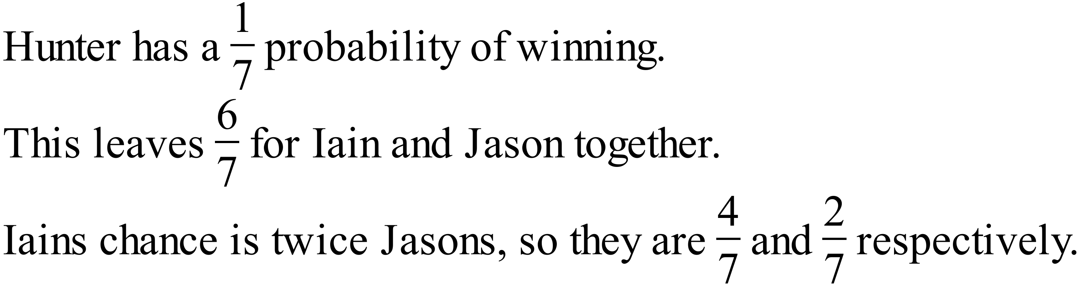 | A
 | 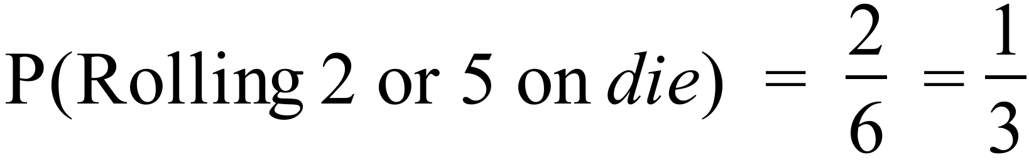  The others will not always have a probability of 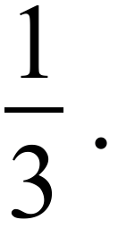 | A
 | 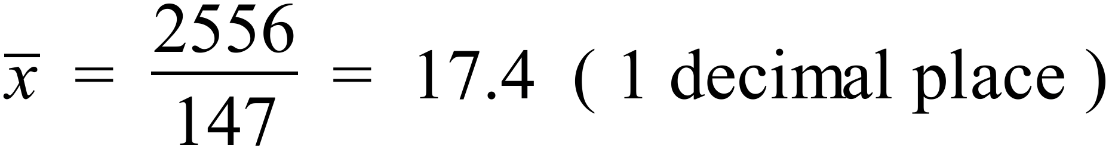  Or by entering data in scientific calculator. | B
  Class Centre | Frequency | fx
  3 | 6 | 18
  8 | 15 | 120
  13 | 35 | 455
  18 | 40 | 720
  23 | 37 | 851
  28 | 14 | 392
   | 147 | 2556
 | - The median is calculated using all the prices and the mean is not.  Both are found using all the prices.  - The median gives a better indication of the spread of the data.  The median gives no indication of the spread.  - The median is less effected by outliers than the mode.  Neither are affected by outliers.  - The median is less effected by outliers than the mean.  The mean can be effected by a few very large (or small) prices. | D
 | Both B and C indicate linear relationships, and C has a positive gradient. | C
 | 16.5% p.a. interest =  Interest =  Amount repaid = $4.33 + $456 = $460.33 | A
 | 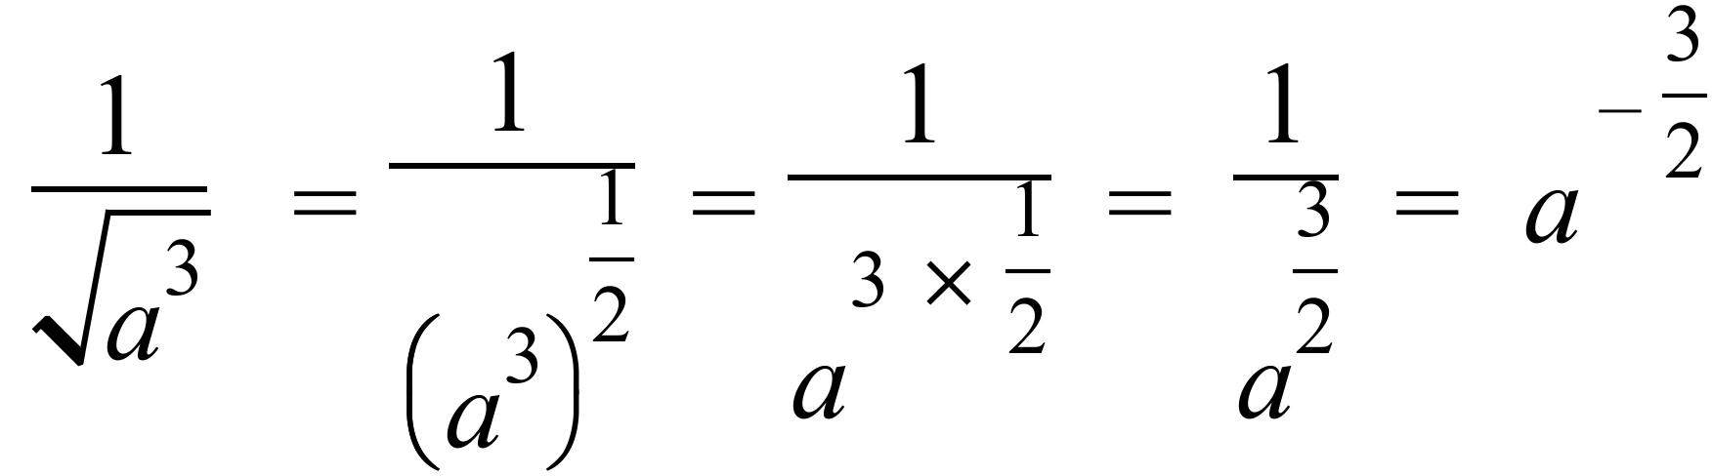 | A
 | 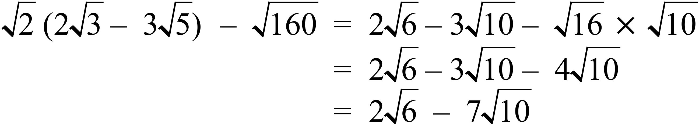 | C
 | 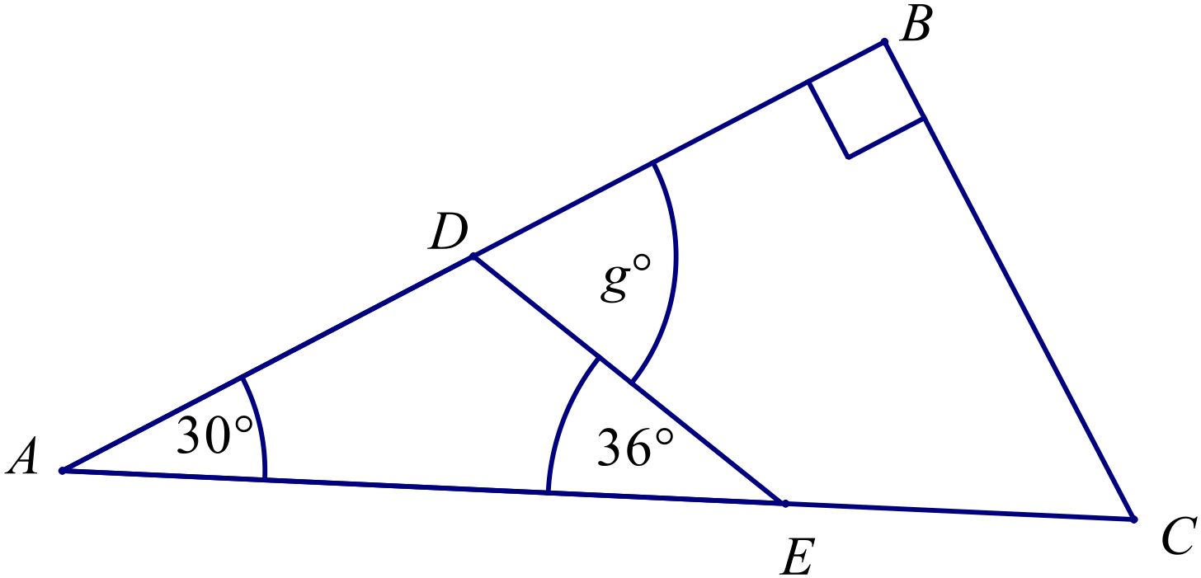  OR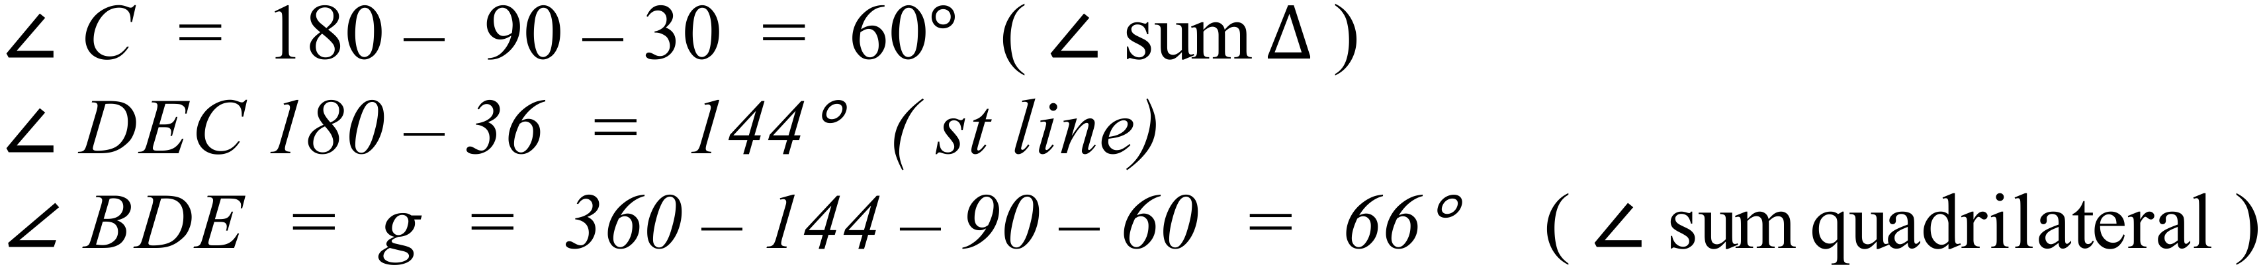  OR  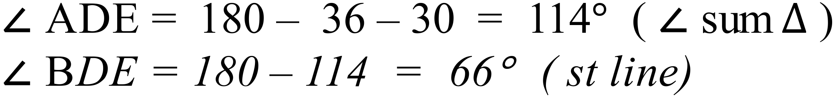 | B
 | The angle sum of a polygon 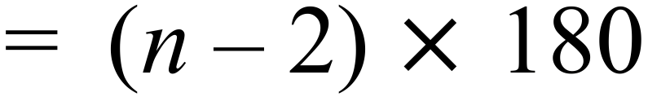  The angle sum of a dodecagon  Interior angle of a regular dodecagon 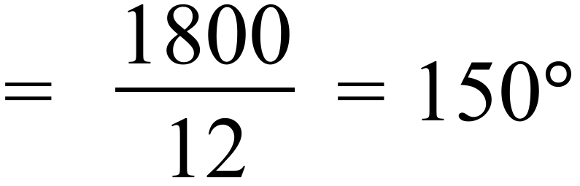 | D
 | 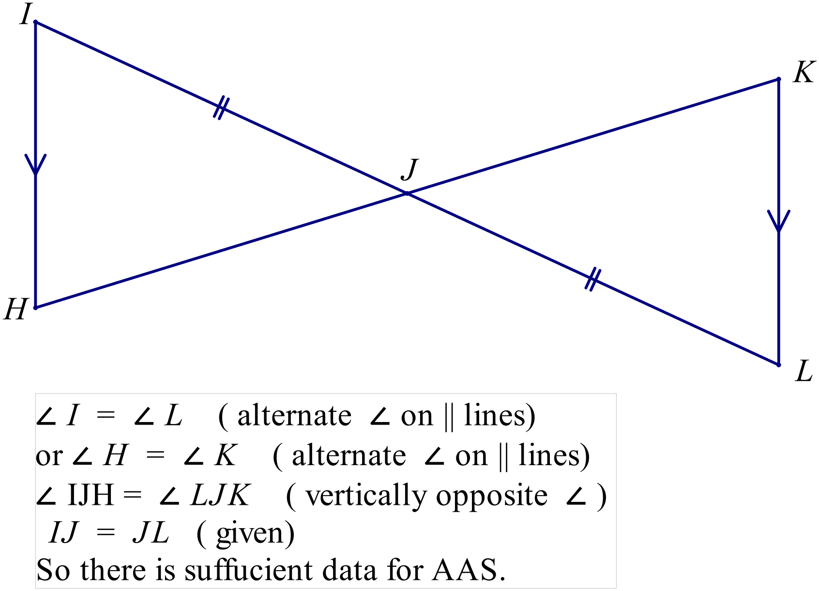 | A
 | 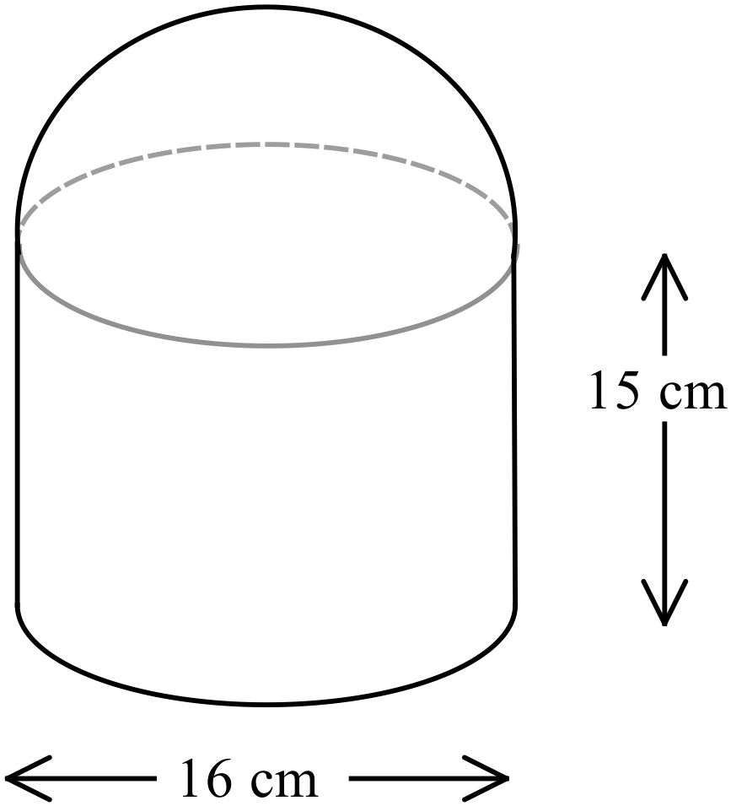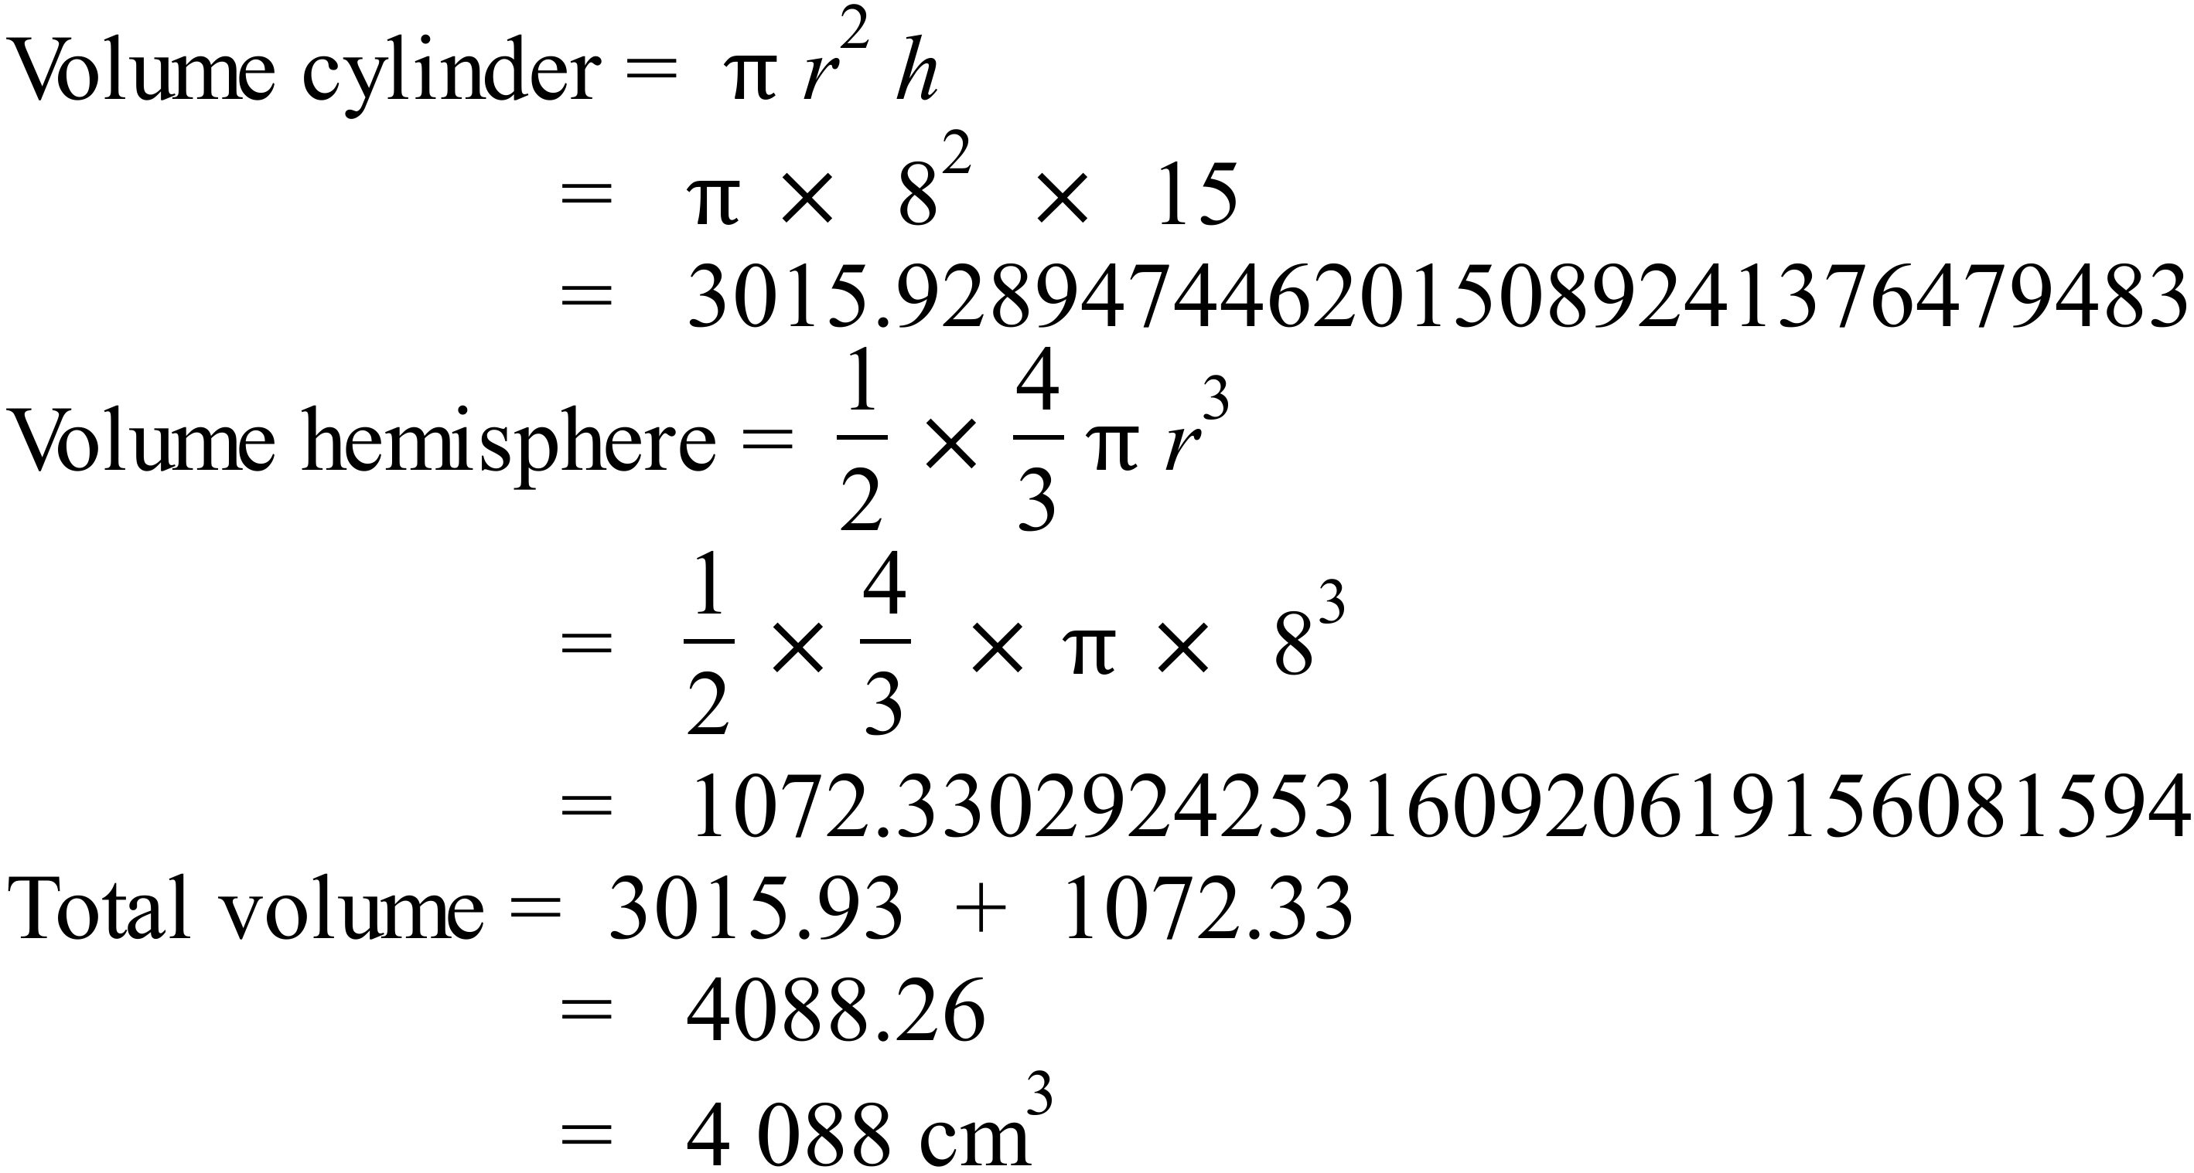 | C
 | 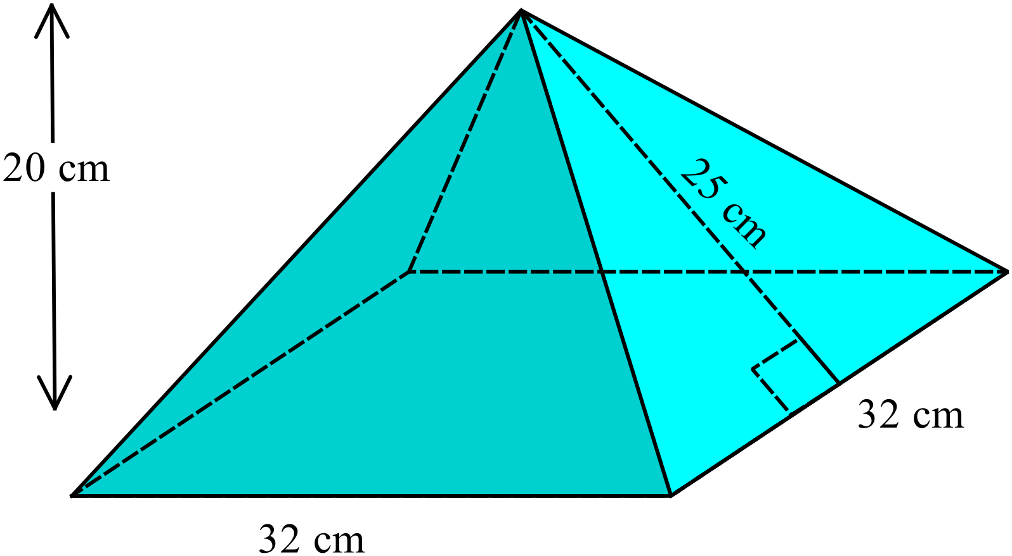  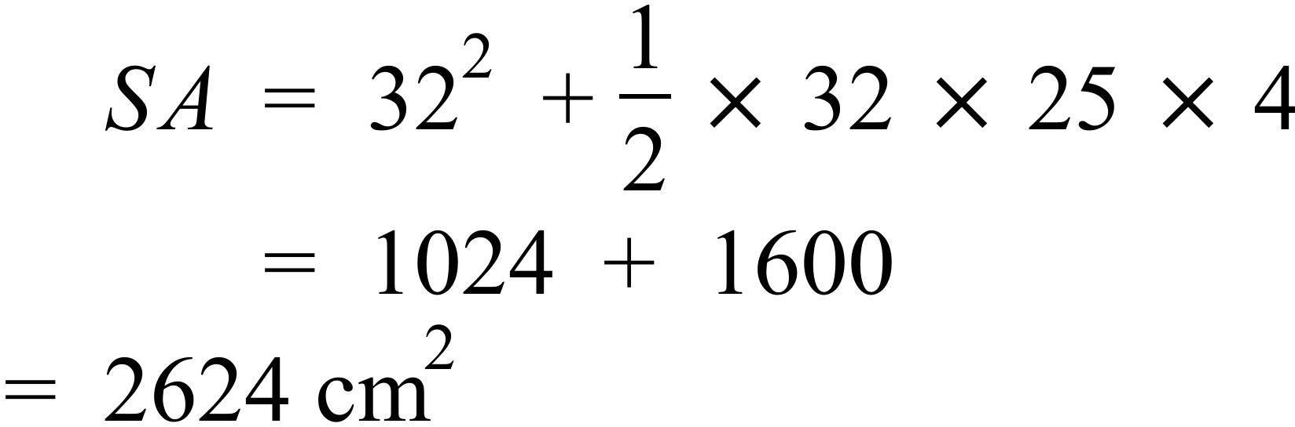 | B
 | 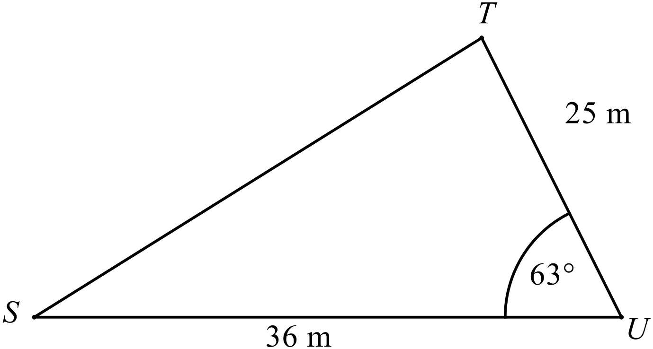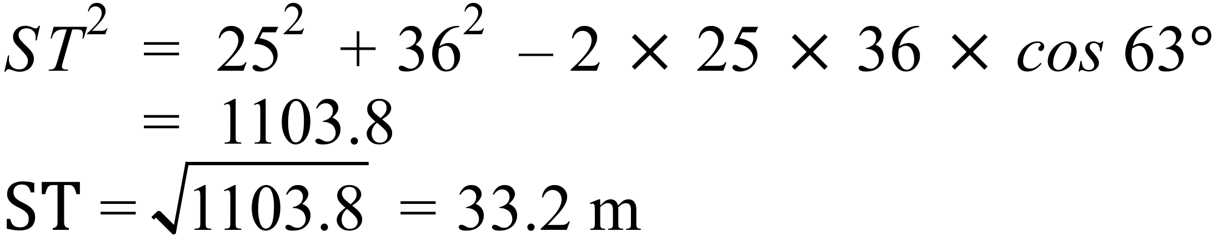 | C
 | 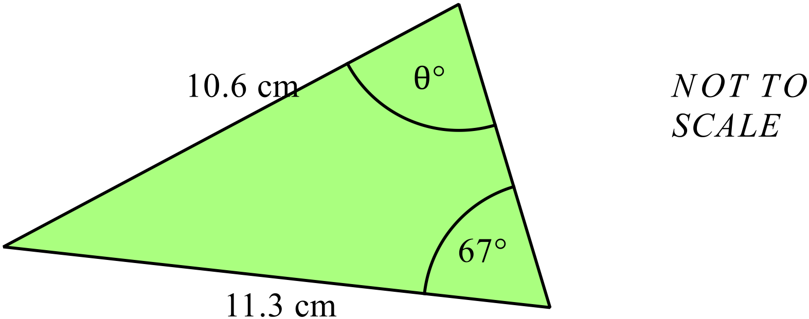  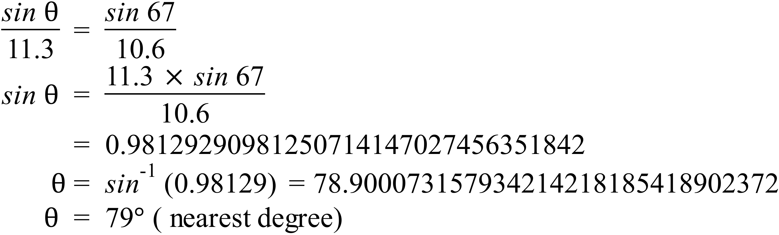 | D
 | The gradient of the line through A(-3, 2) and B(5, -2) 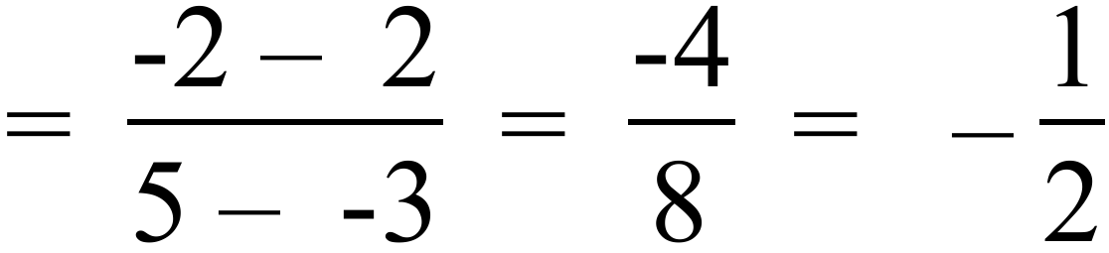  Equation of line : 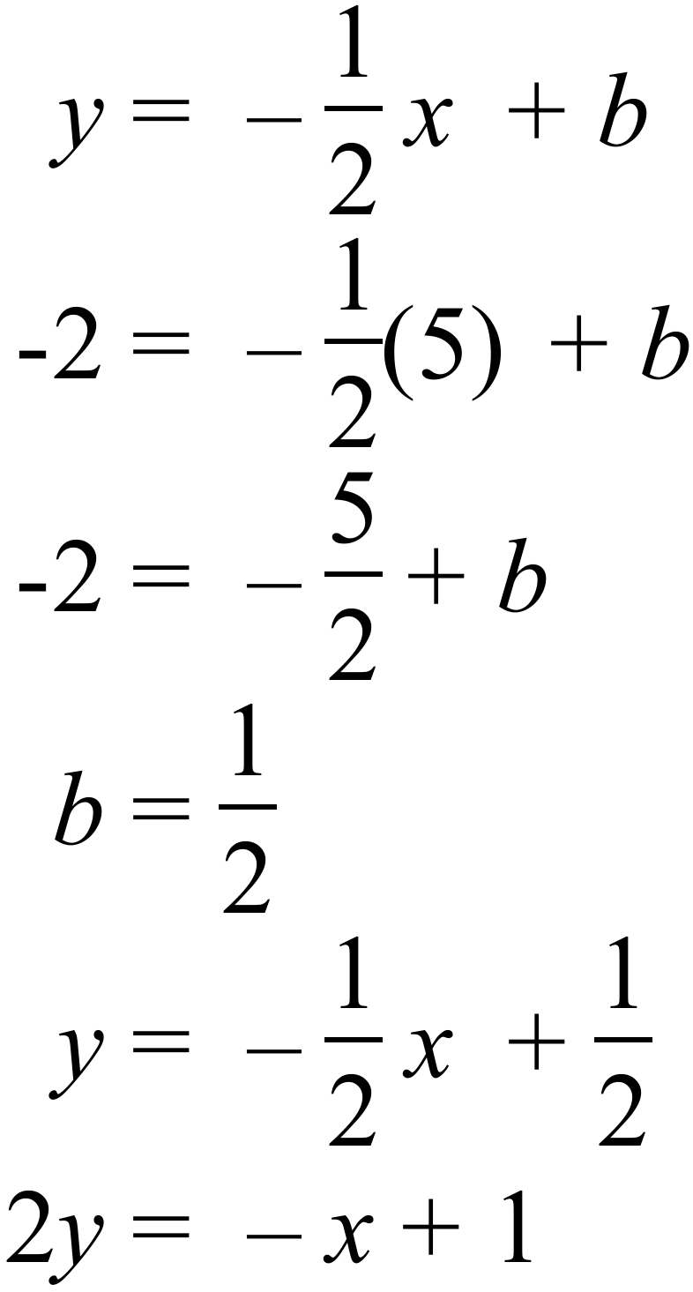  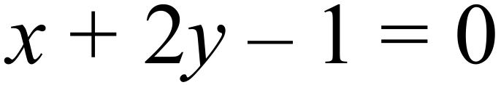 | B
 | 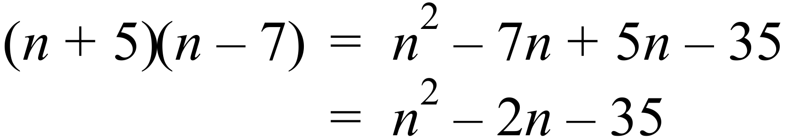 | D
 | 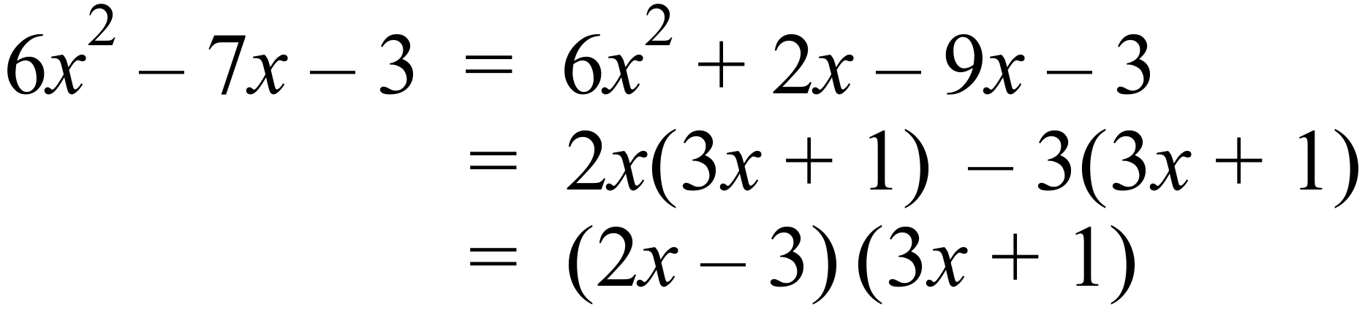 | A
 | Substitute 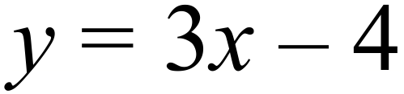 into 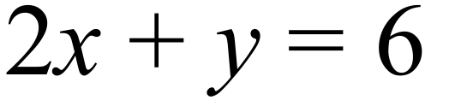  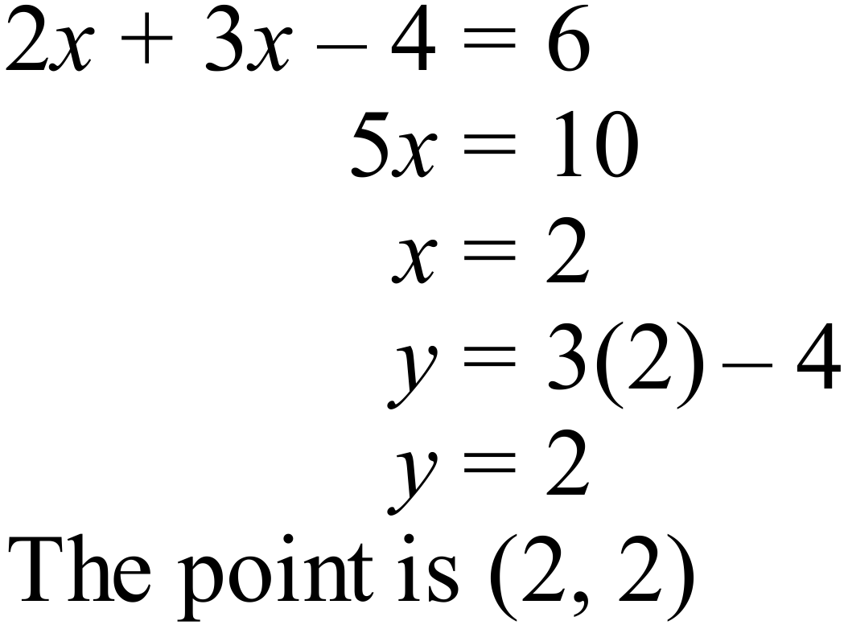 | D
 | Sketch 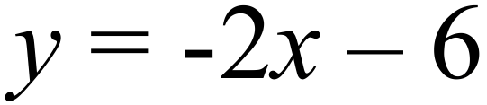  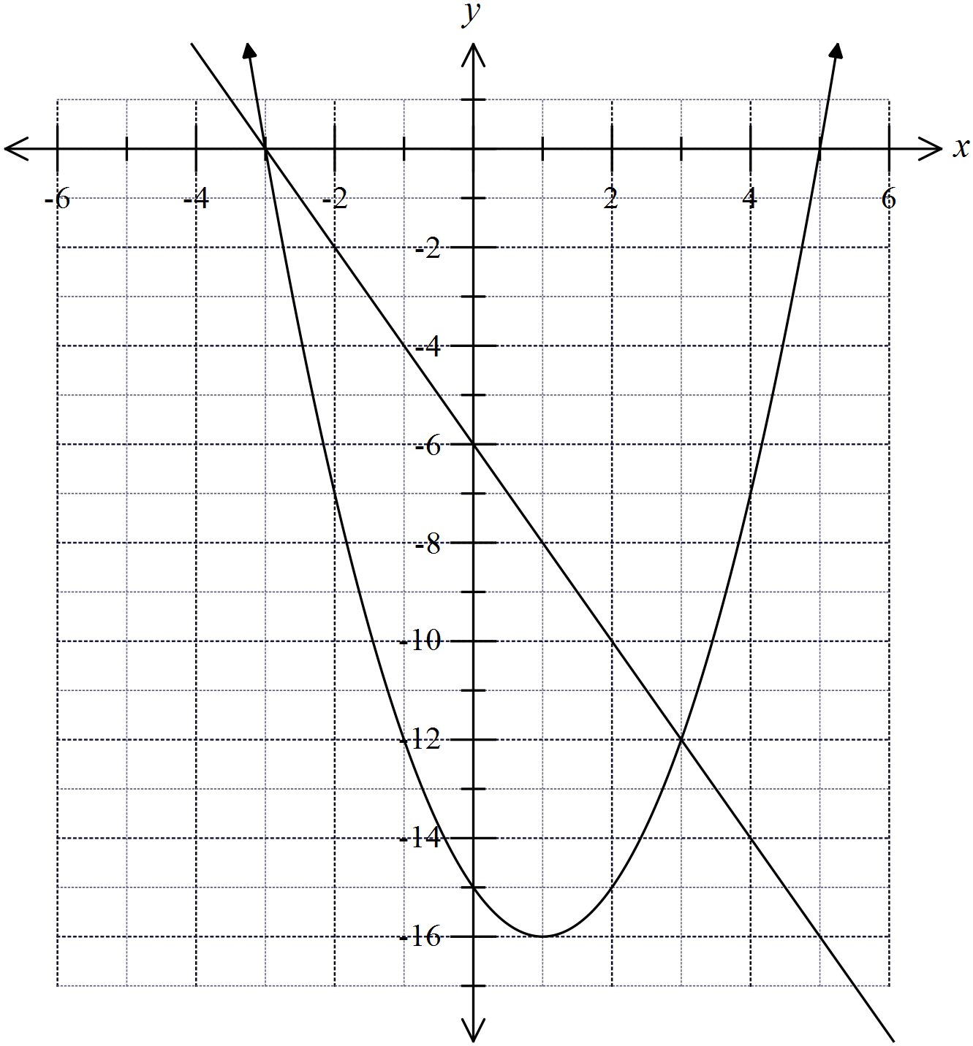  The points are (-3, 0) and (3, -12) | C
 |   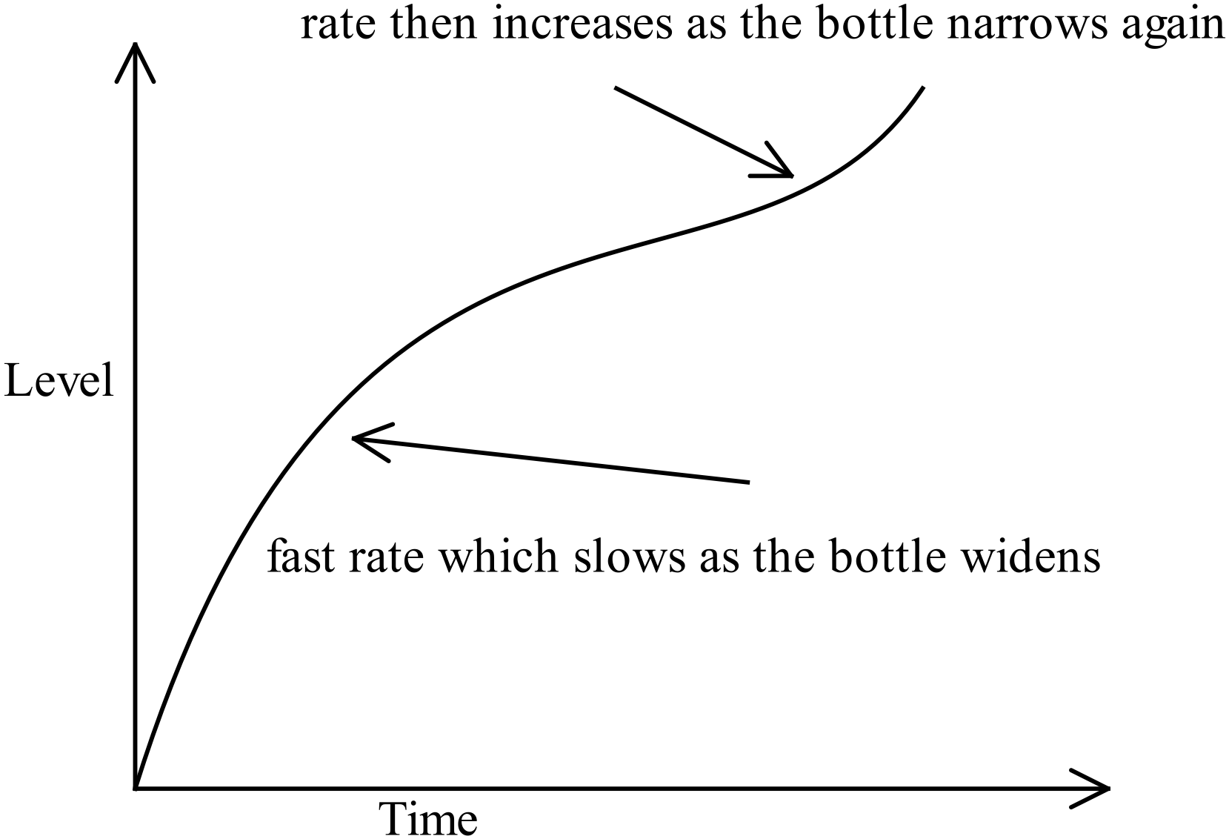 | B
 | 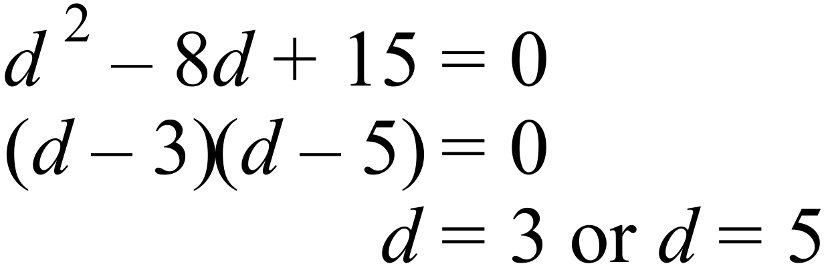 | D
 | 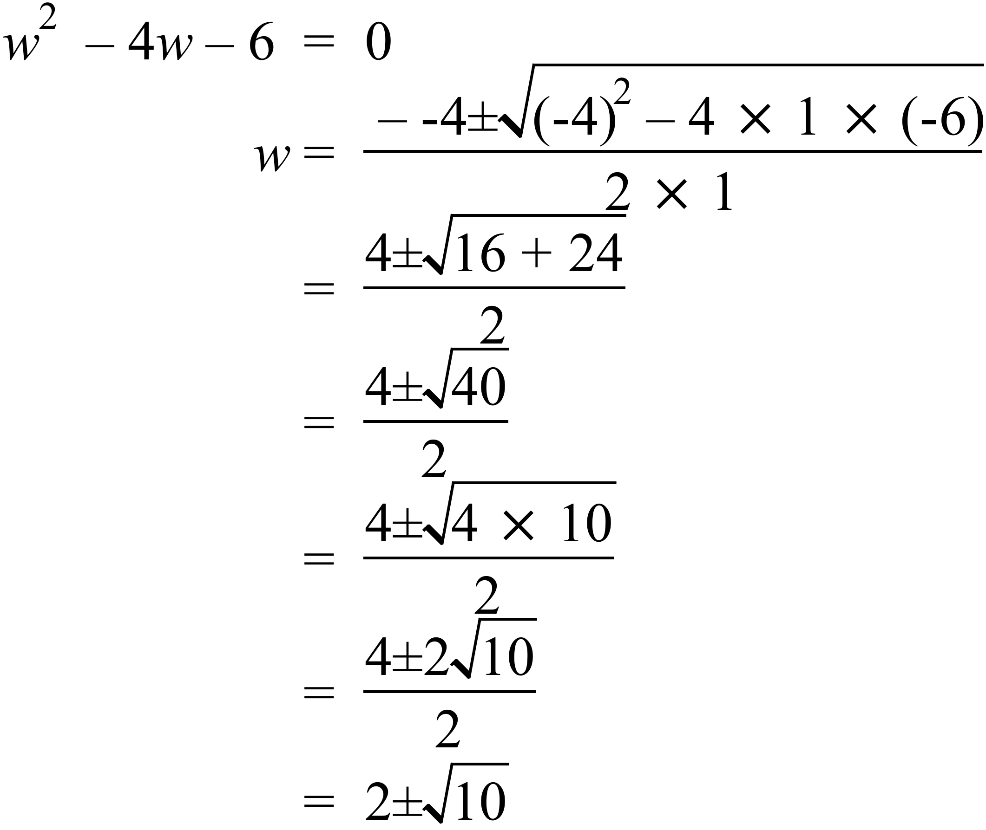 | B
 | 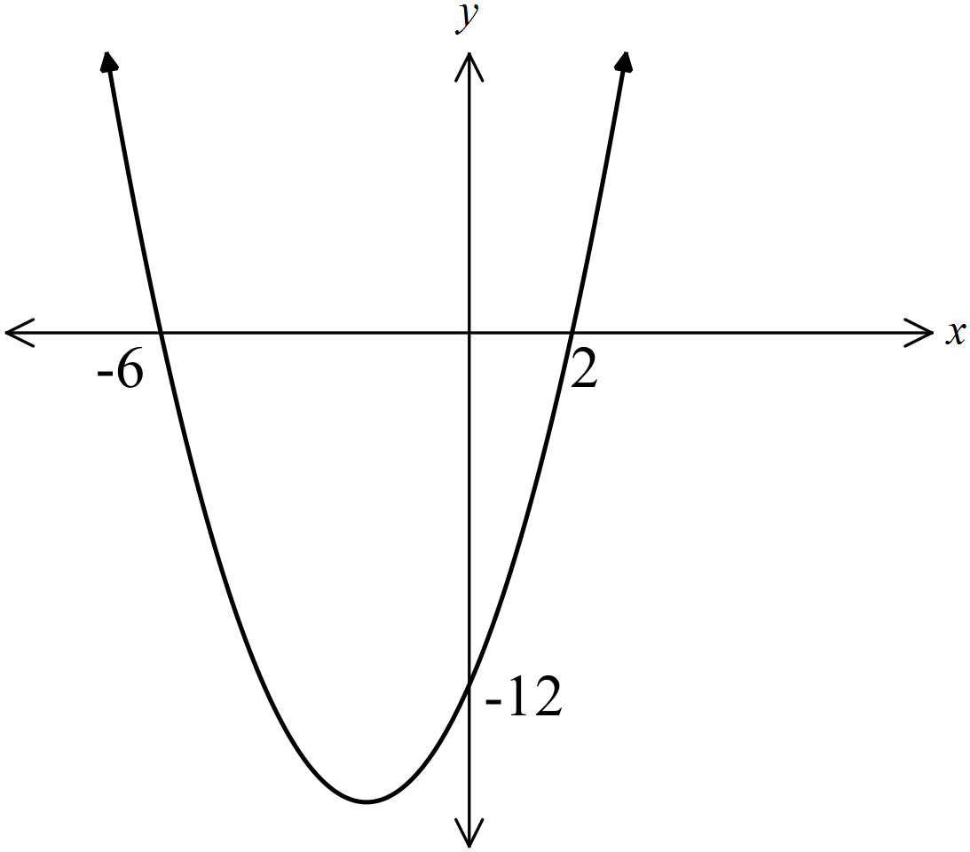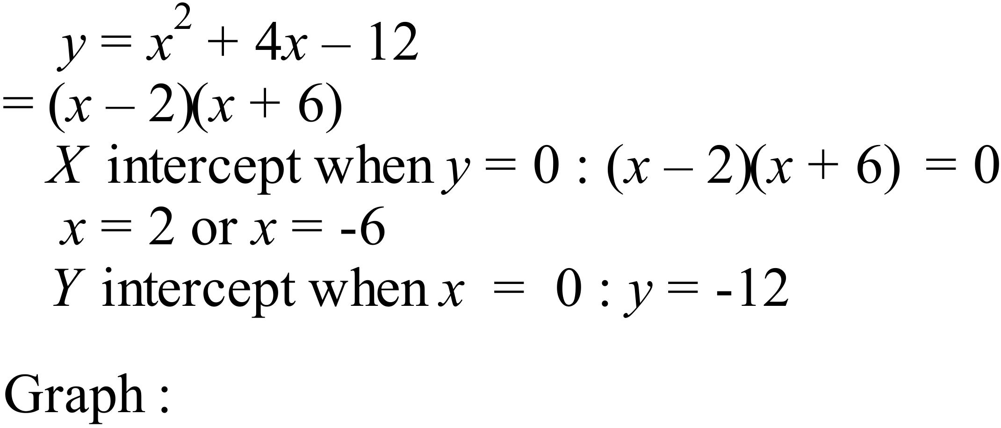 | B
 | Given the point (2, 10) lies on the graph and the shape is a hyperbola. | A
 | Probability that a female chosen supports Tigers = 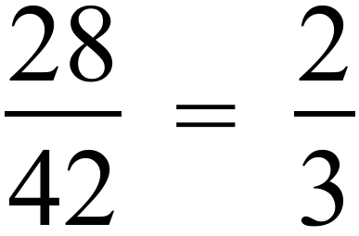 | C
   | Male | Female | Total
  Bulldogs | 26 | 14 | 40
  Tigers | 32 | 28 | 60
  Total | 58 | 42 | 100
 | 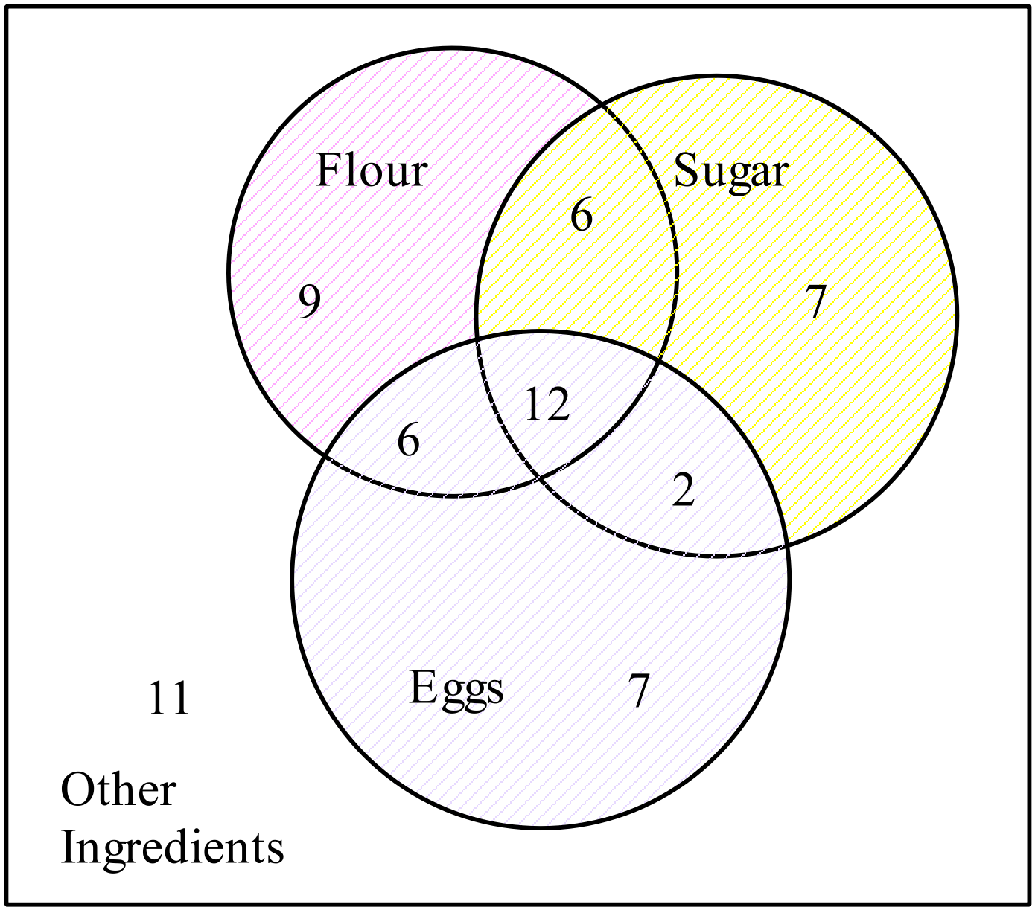  Number of recipes with both flour and sugar = 6 + 12 = 18  Total number of recipes = 6+12+9+7+6+2+7+11 = 60  Probability recipe has flour and sugar = 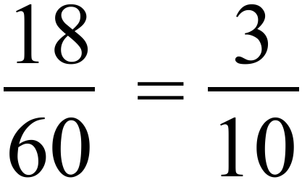 | C
 | From Scientific Calculator | A
 | The scores in a negative skew have a cluster in the higher values and a longer tail toward the lower values, which is illustrated in this box plot.  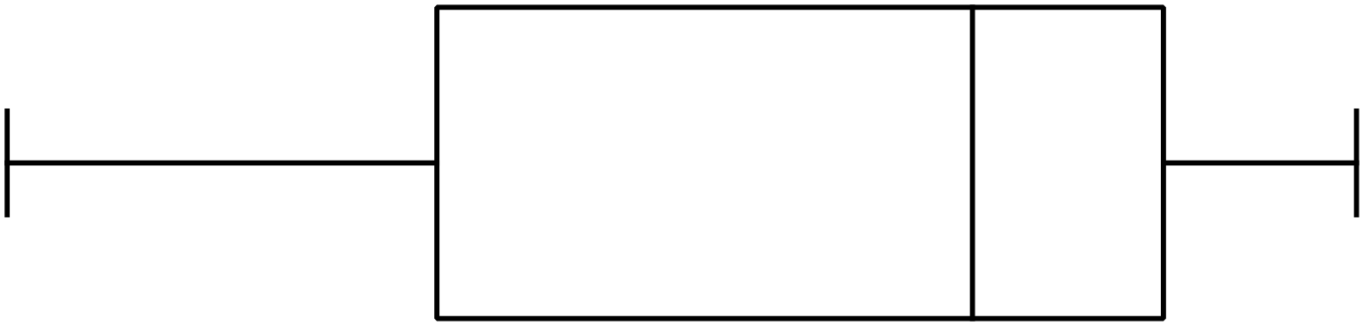 | B
 | - Both brands have an average amount of fibre which is 15 grams or more.  Means (averages) are 15.1 and 15.0 which are both 15 or more.  - Brand A would have the middle 50% of its packets within a 3.6 gram range  The interquartile range for Brand A is 3.6 which means the above.  - Brand B would have 25% of its packets with more than 15.7 grams of fibre.  Since Brand B is symmetrical and has IQR of 1.6, 0.8 of middle 50% would be above median. = 14.9 + 0.8 = 15.7 so 25% are above this,  - Brand B is less consistent in achieving amounts of fibre which are close to their claim.  Brand B has the smaller standard deviation and IQR, so it has more values nearer the mean and median, so it is better at being close to its claim. | D

2014 Yearly Advanced Mathematics Exam
Longer Answer Section
Answers
76. | (a) 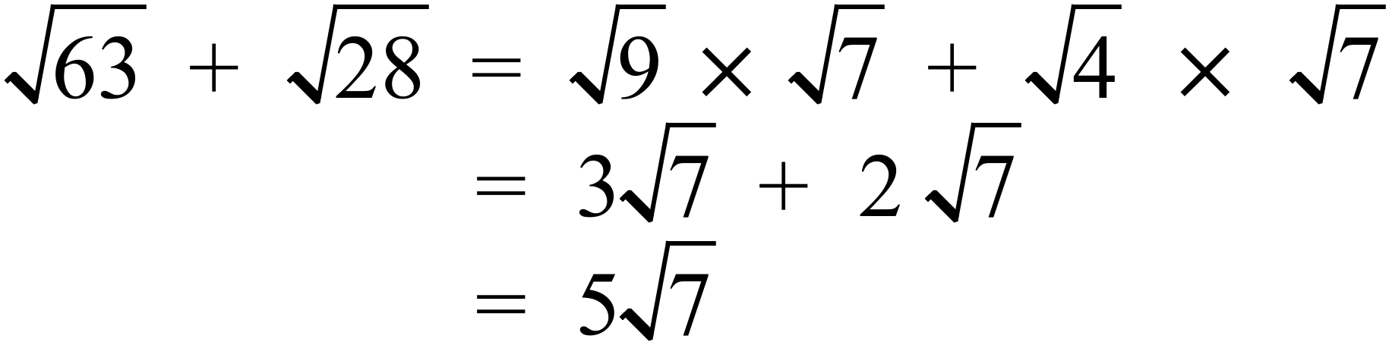 | 1 mark for correct answer.
 | (b) 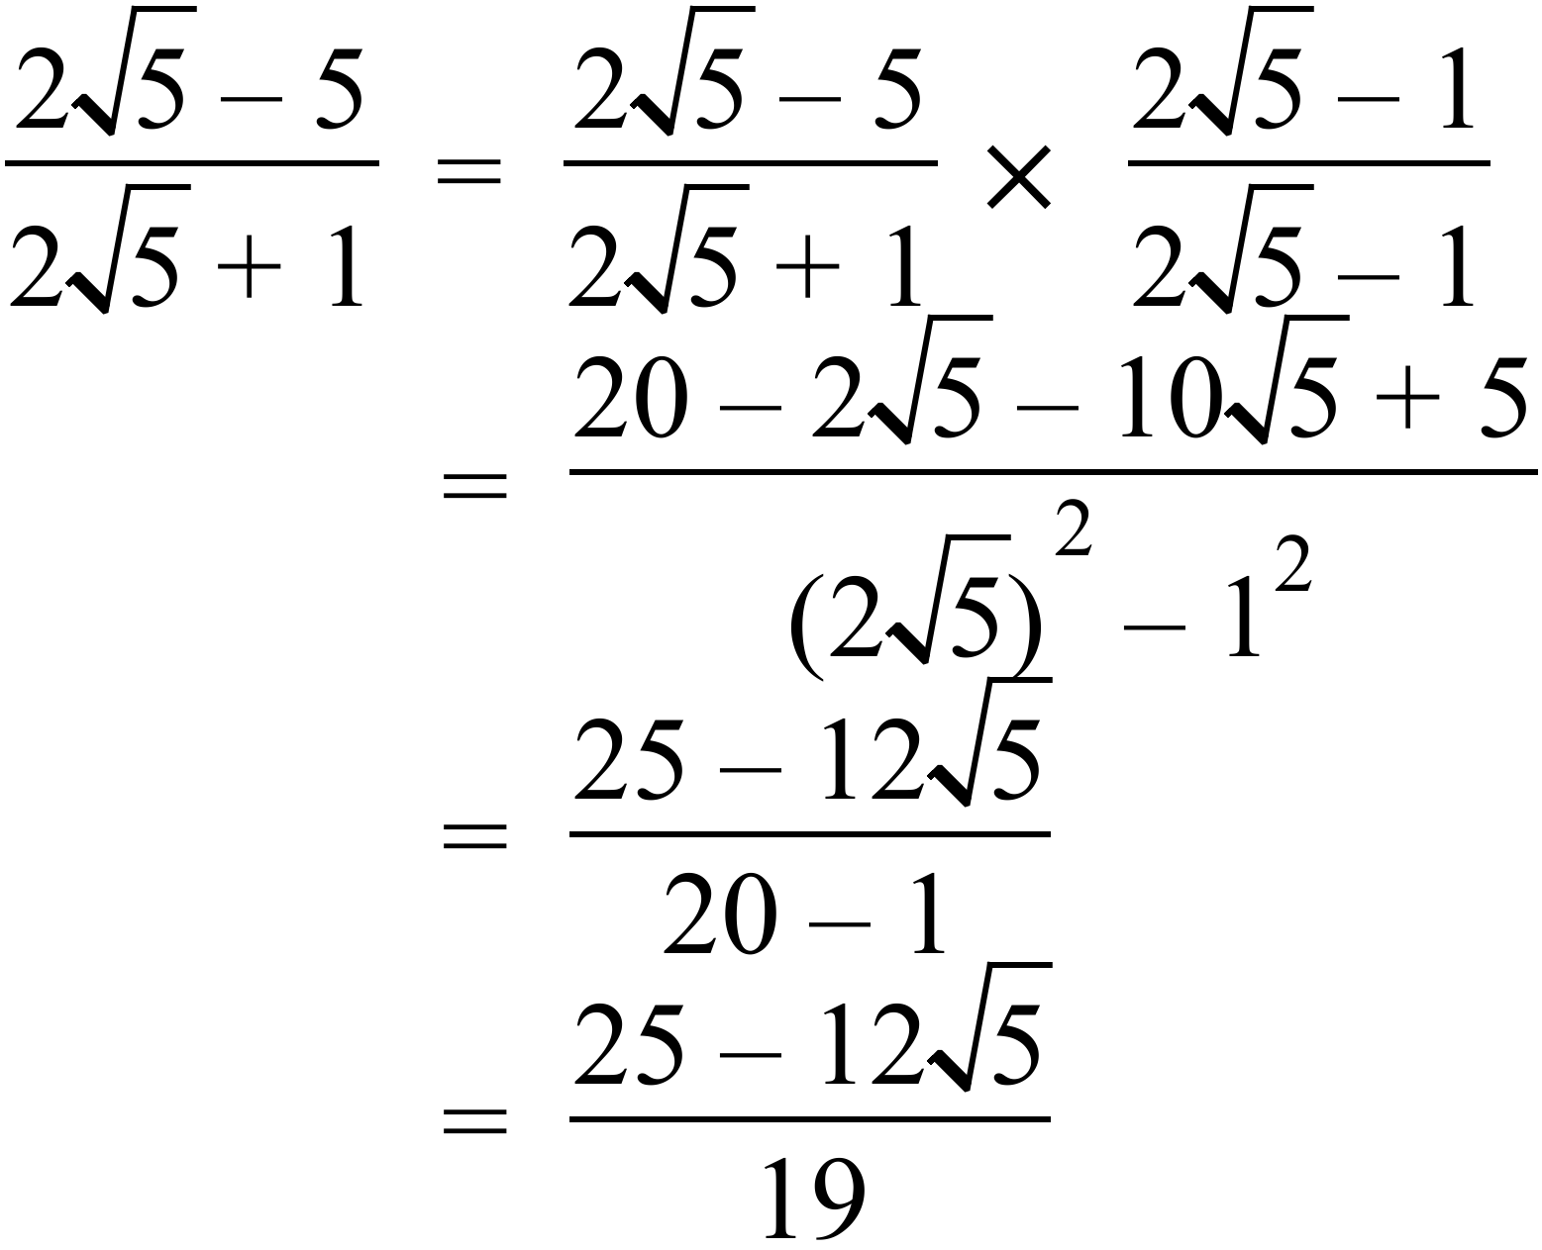 | 2 marks for correct answer.  1 mark if multiplication by conjugate is done with a minor error.
77. | 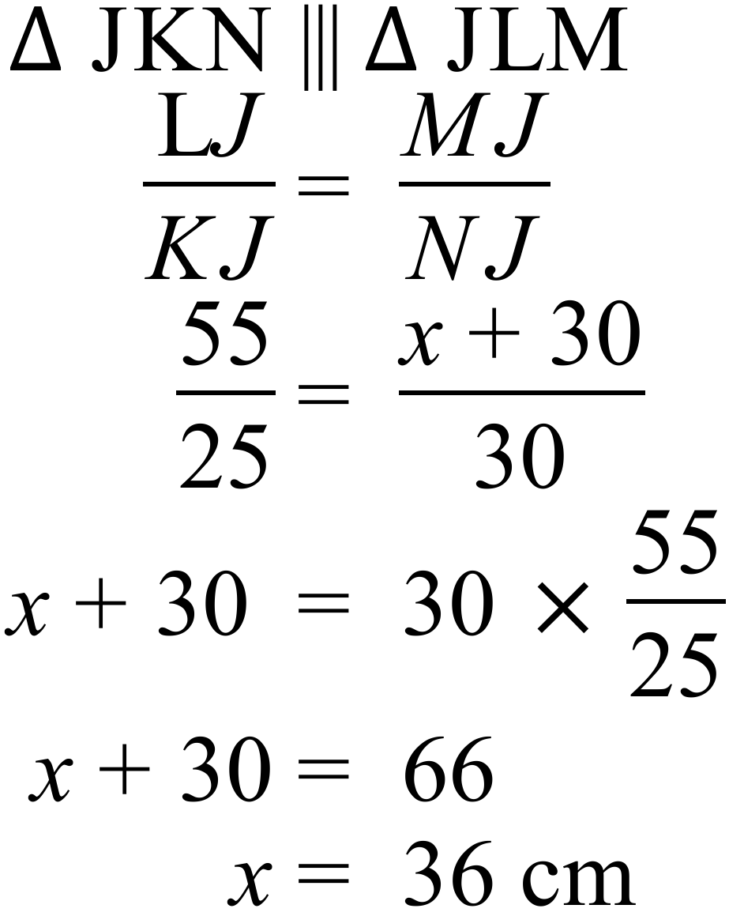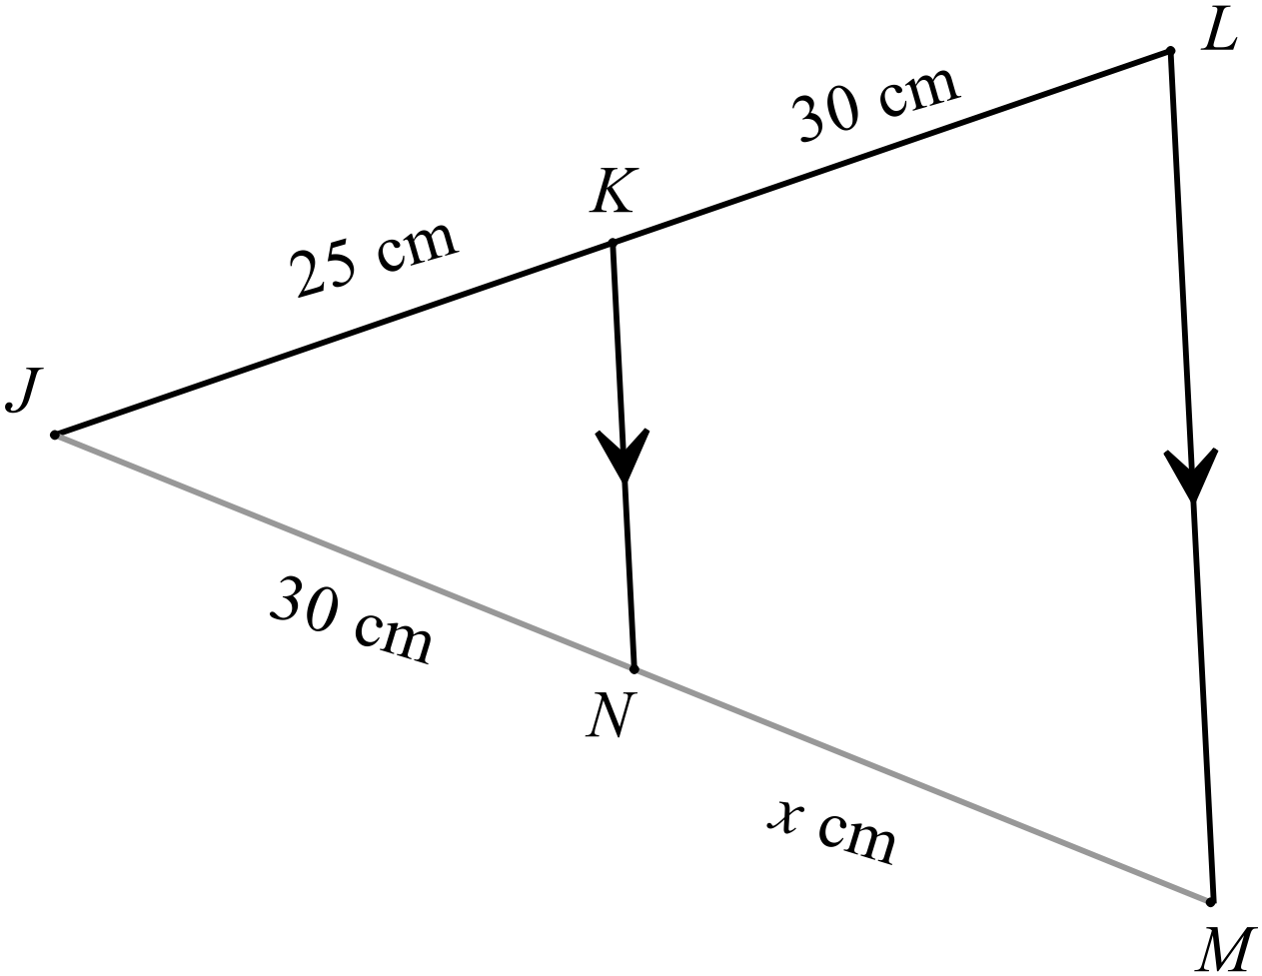 | 2 marks for correct answer.  1 mark if an error made in the ratios, but calculations made correctly.  1 mark if an error made in the calculations, but ratios are written correctly.
78. | 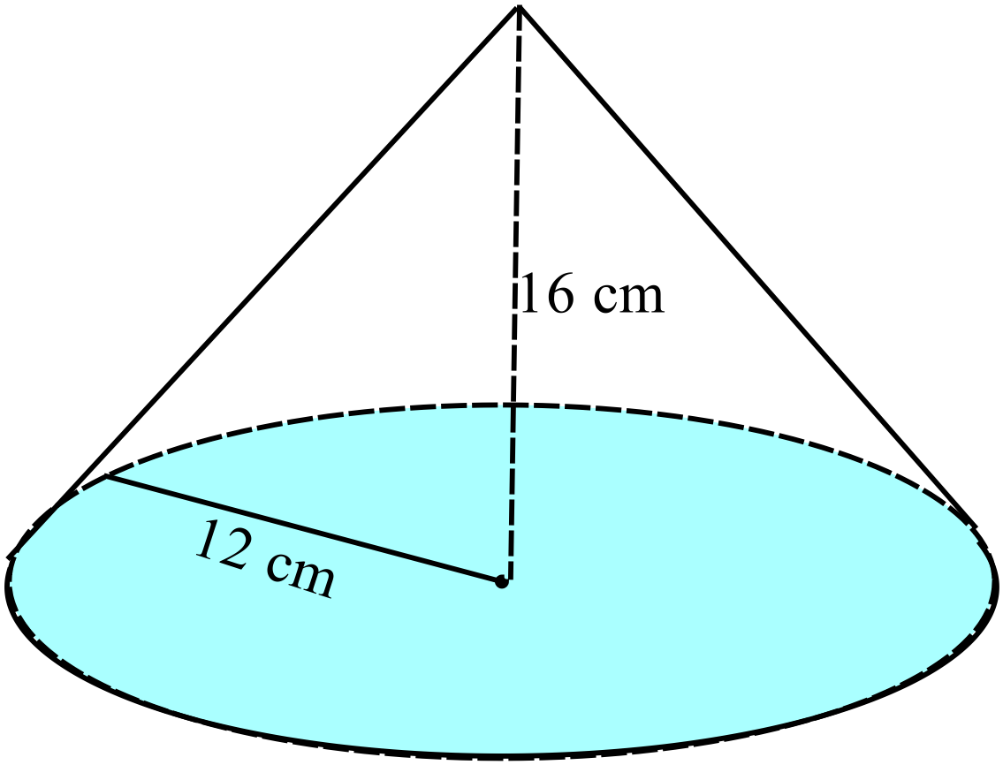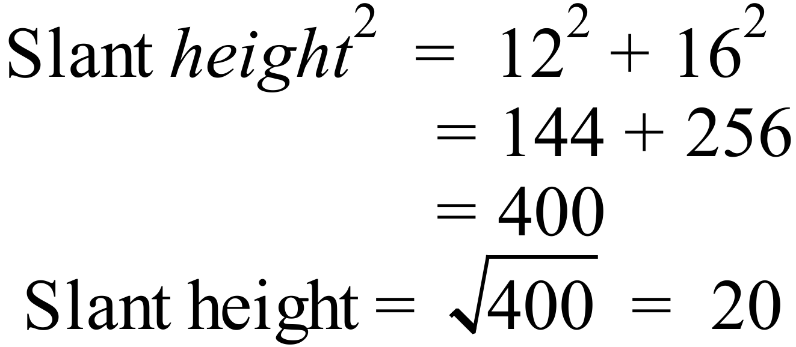  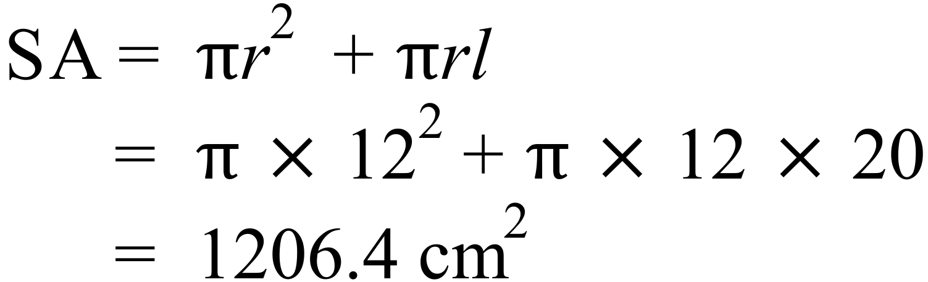 | 2 marks for correct answer.  1 mark if an error made in the formula, but calculations made correctly.  1 mark if an error made in the calculations, but substitution in formula done correctly.
79. | 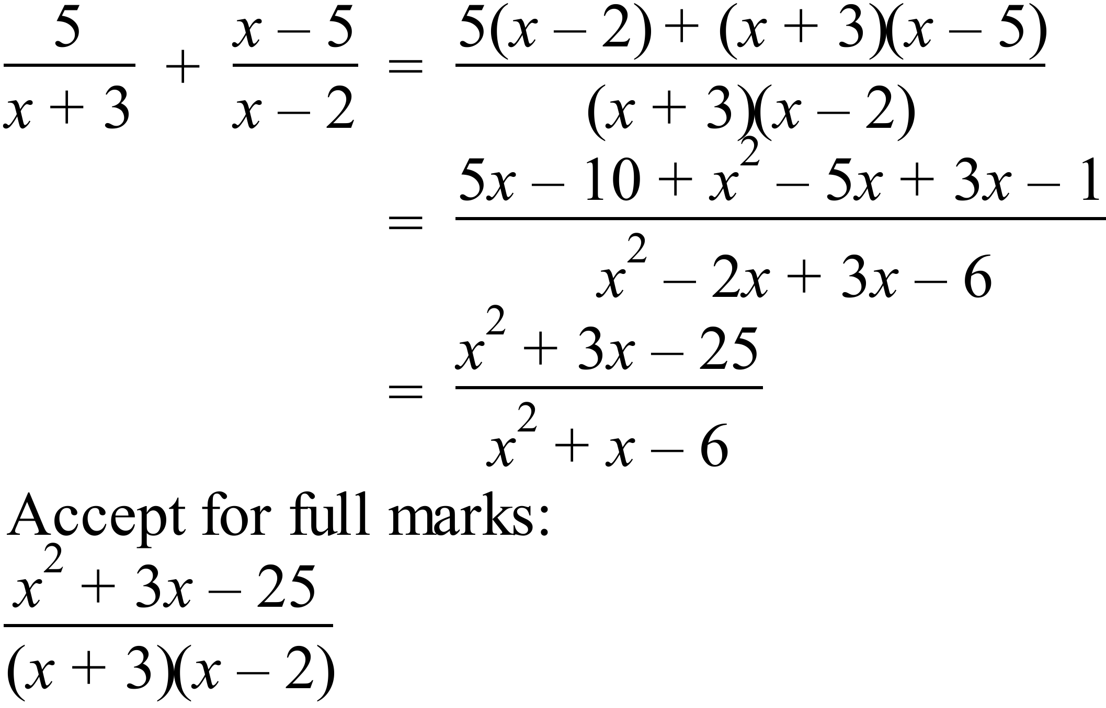 | 2 marks for correct answer  1 mark for answer which has a minor error in expansion or simplification
80. | 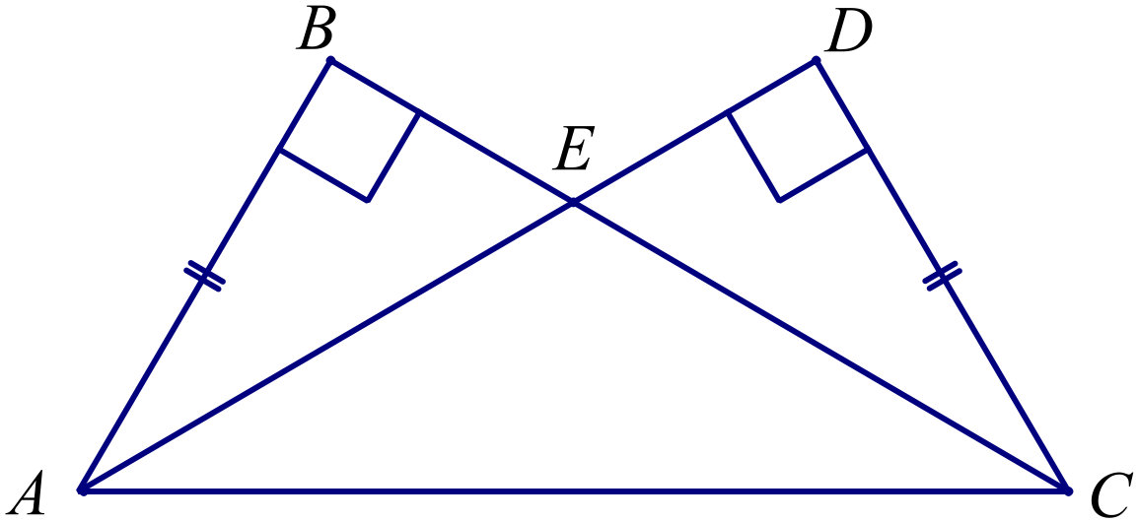
 | (a) 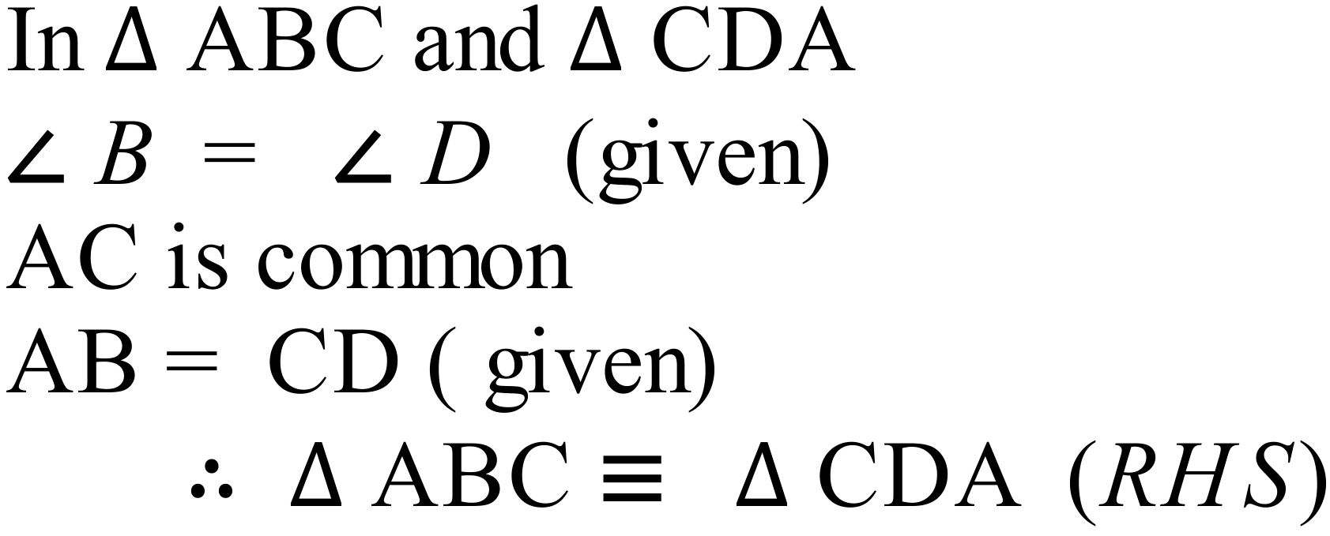 | 2 marks for correct proof with well set out reasoning.  1 mark for attempted proof with an error in the reasoning.
 | (b) 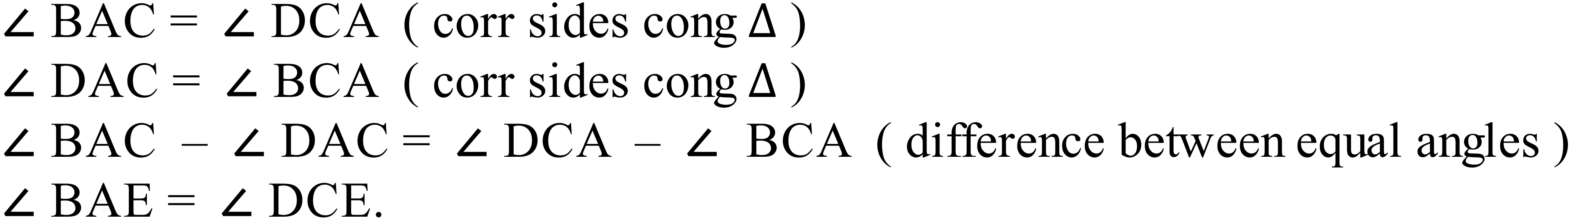  OR  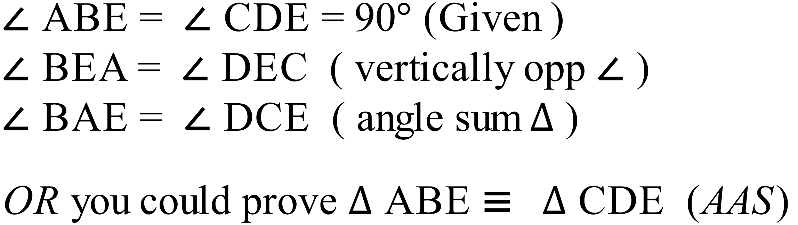 | 1 mark for correct proof with well set out reasoning.
81. | 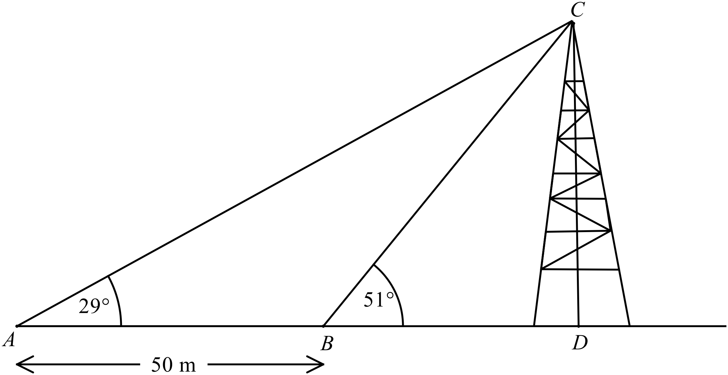
 | (a)  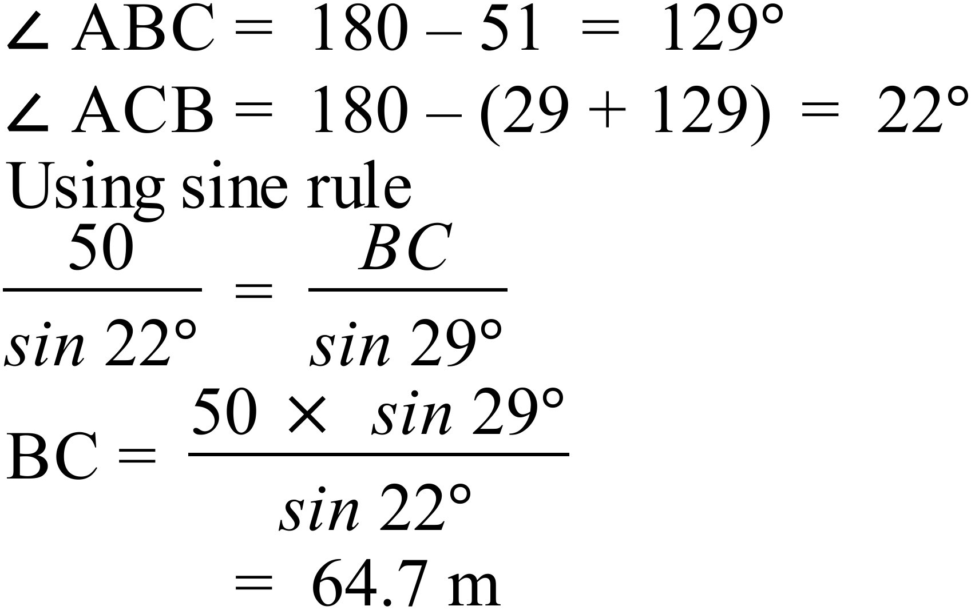 | 1 mark for correct answer
 | (b)  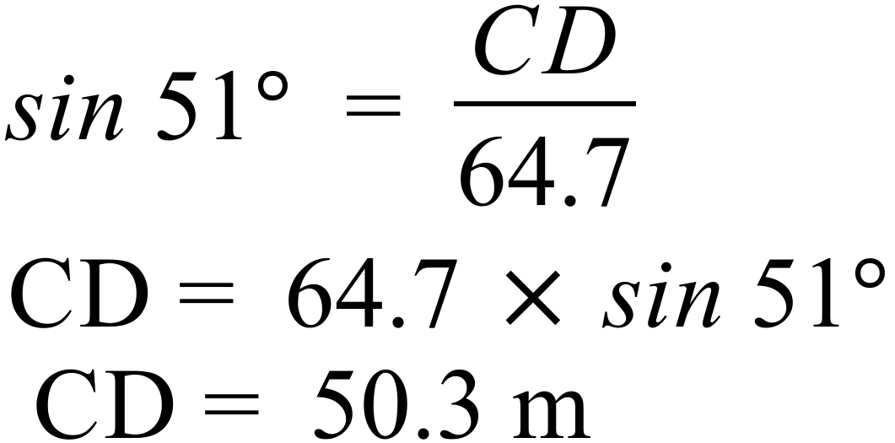 | 1 mark for correct answer
82. | 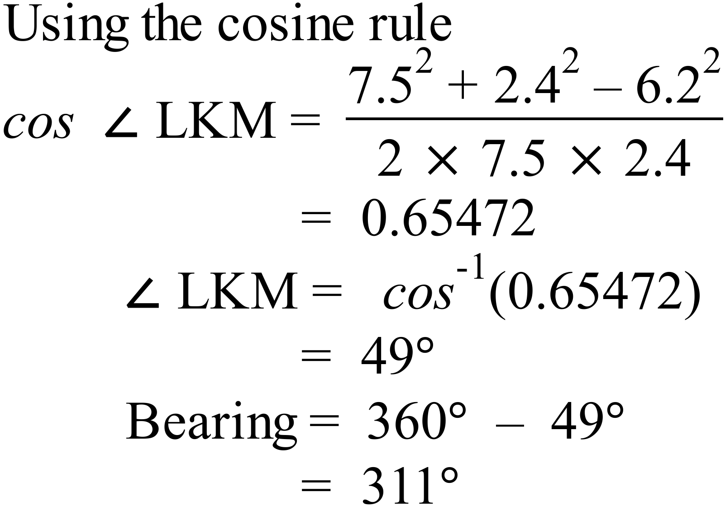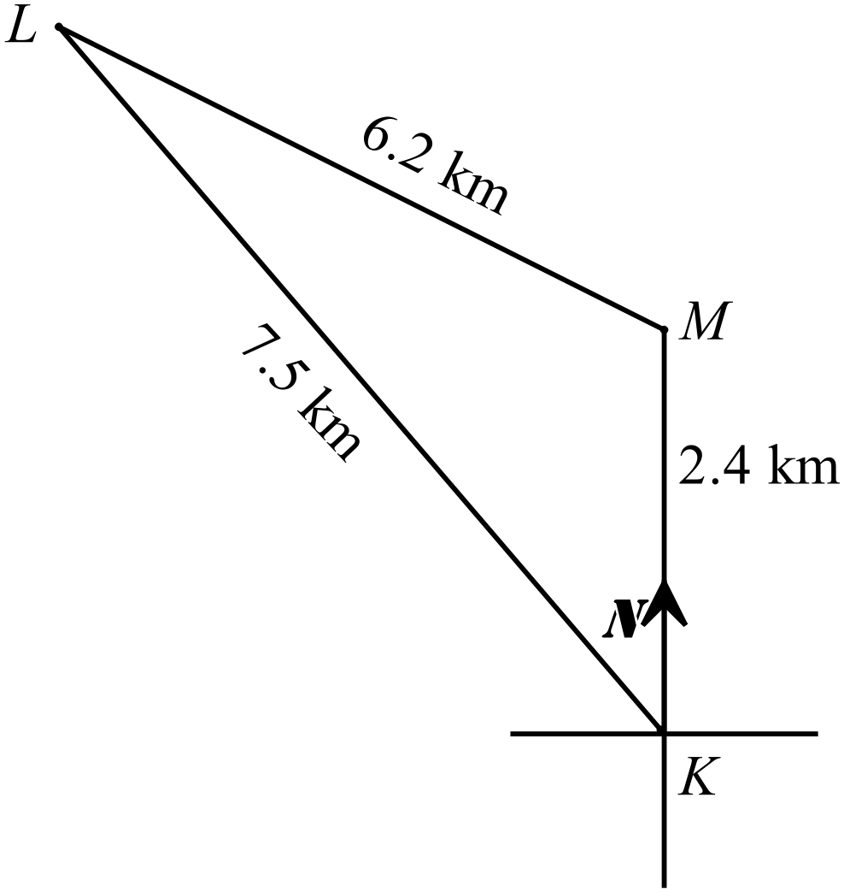 | 2 marks for correct answer.  1 mark if an error made in using the formula, but remainder done correctly.  1 mark if an error made in a calculation, but remainder done correctly.  1 mark if angle found correctly, but bearing not calculated correctly.
83. | (a) 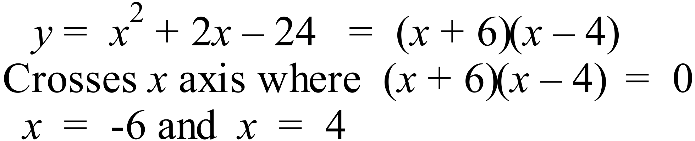 | 1 mark for both values
 | (b) Least value of y on axis, midway between intercepts at x = -1 | 1 mark
 | 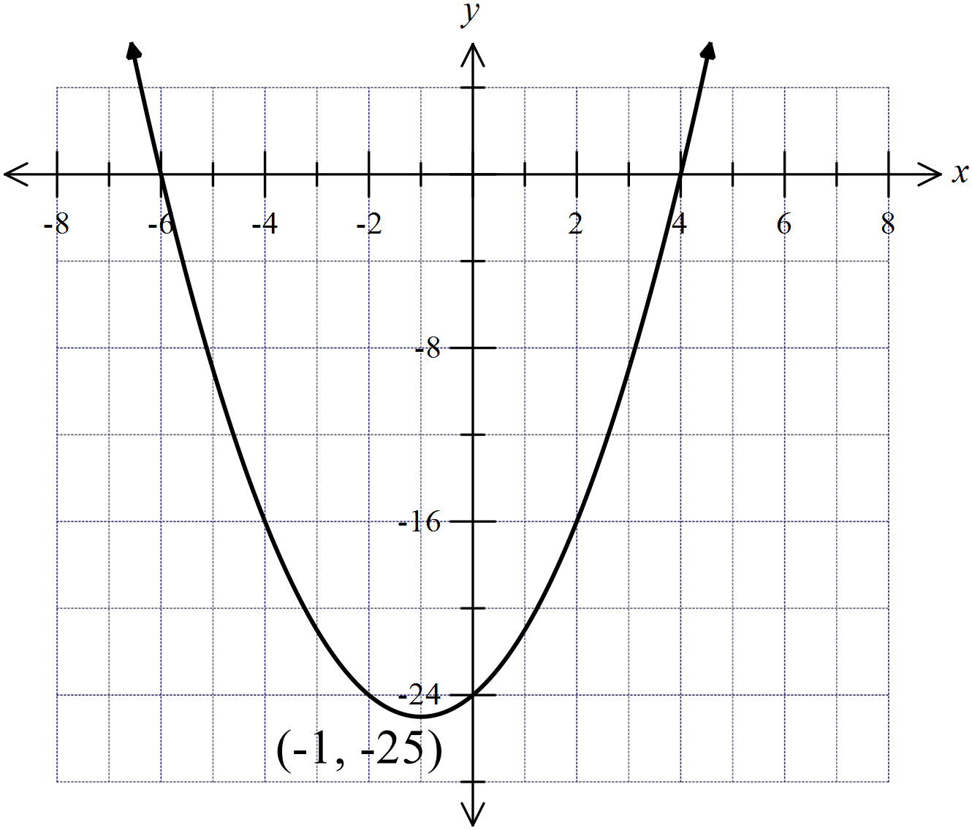(c) | 1 mark for sketch showing intercepts and correct concavity and turning point
84. | (a) | 1 mark if table completed correctly
   | 1 | 2 | 3 | 4 | 5 | 6
  1 | 1, 1 | 1, 2 | 1, 3 | 1, 4 | 1, 5 | 1, 6
  2 | 2, 1 | 2, 2 | 2, 3 | 2, 4 | 2, 5 | 2, 6
  3 | 3, 1 | 3, 2 | 3, 3 | 3, 4 | 3, 5 | 3, 6
  4 | 4, 1 | 4, 2 | 4, 3 | 4, 4 | 4, 5 | 4, 6
  5 | 5, 1 | 5, 2 | 5, 3 | 5, 4 | 5, 5 | 5, 6 | Product 12
  6 | 6, 1 | 6, 2 | 6, 3 | 6, 4 | 6, 5 | 6, 6
 | (b) 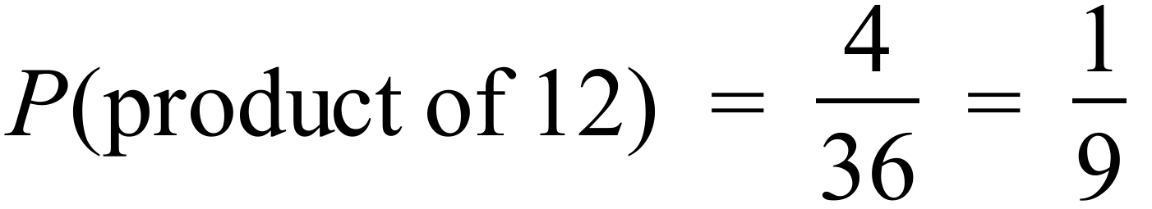 | 1 mark for answer
85. | (a) From Scientific calculator ; | 1 mark for each
 | (b) The data is positively skewed with an outlier at 27 | 1 mark if skew and outlier is mentioned

High School
2014 Yearly Exam
Advanced Mathematics Course
Multiple Choice Section Answer Sheet
Name ____MARKING SHEET Teacher ________________________
Completely fill the response oval representing the most correct answer.

26. A B C D
27. A B C D
28. A B C D
29. A B C D
30. A B C D
31. A B C D
32. A B C D
33. A B C D
34. A B C D
35. A B C D
36. A B C D
37. A B C D
38. A B C D
39. A B C D
40. A B C D
41. A B C D
42. A B C D
43. A B C D
44. A B C D
45. A B C D
46. A B C D
47. A B C D
48. A B C D
49. A B C D
50. A B C D
51. A B C D
52. A B C D
53. A B C D
54. A B C D
55. A B C D
56. A B C D
57. A B C D
58. A B C D
59. A B C D
60. A B C D
61. A B C D
62. A B C D
63. A B C D
64. A B C D
65. A B C D
66. A B C D
67. A B C D
68. A B C D
69. A B C D
70. A B C D
71. A B C D
72. A B C D
73. A B C D
74. A B C D
75. A B C D

